

Hydrological Sciences Journal

ISSN: 0262-6667 (Print) 2150-3435 (Online) Journal homepage: www.tandfonline.com/journals/thsj20

Predicting daily streamflow in ungauged rural catchments: the case of Masinga catchment, Kenya
BENEDICT MWAVU MUTUA & ANDREAS KLIK

To cite this article: BENEDICT MWAVU MUTUA & ANDREAS KLIK (2007) Predicting daily streamflow in ungauged rural catchments: the case of Masinga catchment, Kenya, Hydrological Sciences Journal, 52:2, 292-304, DOI: 10.1623/hysj.52.2.292
To link to this article: https://doi.org/10.1623/hysj.52.2.292

 Published online: 18 Jan 2010.

 Submit your article to this journal 

 Article views: 1515

 View related articles

 Citing articles: 1 View citing articles

Full Terms & Conditions of access and use can be found at https://www.tandfonline.com/action/journalInformation?journalCode=thsj20

Predicting daily streamflow in ungauged rural catchments: the case of Masinga catchment, Kenya

BENEDICT MWAVU MUTUA^{1,2} & ANDREAS KLIK²
- Department of Agricultural Engineering, Egerton University, Box 536, Njoro, Kenya
- Institute of Hydraulics and Rural Water Management, University of Natural Resources and Applied Life Sciences, 18 Muthgasse, 1190, Vienna, Austria
bmmutua@yahoo.com

Abstract Access to daily streamflow data at the catchment scale, is a central component of many aspects of water resources and water quality management. However, the majority of river reaches in many catchments in Kenya are ungauged or poorly gauged, and in some cases existing measurement networks are declining. Long-term continuous monitoring is not being done due to high costs of equip- ment maintenance. Therefore, there is a need for an alternative tool such as a catchment-scale hydro- logical model that is capable of predicting the daily streamflow. An approach is presented of predicting daily streamflow using a physically-based catchment-scale model, the geospatial Stream Flow Model (SFM). The SFM was developed using the “C” programming language and the user interface was developed using the Avenue script of the ArcView software. The SFM simulates the dynamics of runoff processes by utilizing remotely sensed and widely available global or local data sets. The model was applied in the Masinga catchment, Kenya, and the results gave a model performance coefficient of 0.74 based on the Nash-Sutcliffe statistical criterion.
Key words ArcView GIS; daily streamflow; hydrological modelling; Masinga catchment, Kenya; Stream Flow Model; ungauged catchment

Prévision de l’écoulement journalier dans des bassins versants ruraux non jaugés: le cas du bassin versant de Masinga, Kenya
Résumé L’accès aux données d’écoulement journalier à l’échelle du basin versant est une composante centrale de nombreux aspects de la gestion des ressources en eau et de la qualité de l’eau. Cependant, la majorité des cours d’eau de nombreux bassins du Kenya ne sont pas ou sont peu jaugés, et dans certains cas les réseaux de mesure existants sont en déclin. Le suivi continu sur le long terme n’est pas assuré à cause des coûts élevés de maintenance des équipements. Un outil alternatif est par conséquent nécessaire, comme un modèle hydrologique de bassin versant capable de prévoir l’écoulement journalier. Une approche de prévision de l’écoulement journalier est présentée, basée sur un modèle à bases physiques à l’échelle du bassin versant, le “geospatial Stream Flow Model” (SFM). Le SFM a été développé avec le langage de programmation C tandis que l’interface utilisateur a été développée avec le script Avenue du logiciel ArcView. Le SFM simule la dynamique des processus d’écoulement en utilisant des jeux de données globaux et locaux largement disponibles obtenus par télédétection. Le modèle a été appliqué au bassin versant de Masinga, au Kenya, et les résultats ont donné un coefficient de performance de modélisation de 0.74 basé sur le critère statistique de Nash-Sutcliffe.
Mots clefs SIG ArcView; écoulement journalier; modélisation hydrologique; bassin versant de Masinga, Kenya; Stream Flow Model; bassin non jaugé

INTRODUCTION
Producing streamflow estimates for ungauged catchments has attracted a lot of interest among hydrologists and hydraulic engineers, but the problem still remains unresolved (Nandakumar & Mein, 1997). Estimates of the magnitude and frequency of streamflow are needed to safely and economically design hydraulic structures such as dams, bridges and culverts (Scott et al., 2003). These estimates also are used for managing flood plains, identifying flood-hazard areas, and establishing flood-insurance rates, but may be required at ungauged sites where no observed flood data are available for streamflow- frequency analysis (Feaster & Tasker, 2002). The problem is compounded by the impacts of human-induced changes to the land surface and climate, occurring at the local, regional and global scales (Niehoff et al., 2002). Predictions of ungauged or poorly gauged catchments under these conditions are highly uncertain. Still, it is fore- seeable that estimates of streamflow in ungauged catchments continue to be needed. In

fact, many of the most acute problems concerning water quantity and quality are found in the developing countries, where long data records are not at hand.
Although the problems of flood protection and water resources management continue to be of importance for the security of communities and for human, social and economic development within the Masinga catchment, understanding of hydrological processes in this catchment is not adequate. River systems are the major source of water for agricultural and urban water needs in Kenya, but water quality assessments of the river systems still remain difficult within the Masinga catchment, and there is a concern about the sustainable supply of quality water. There is a need to have a monitoring system in order to assess the effects of different land management practices on water quantity and quality within the major catchments in the country. But, long-term con- tinuous monitoring is not being conducted due to high costs of installing and maintaining the gauging equipment. Hence, there is a need for an alternate tool such as a catchment- scale hydrological model that is capable of predicting the streamflow changes as a result of land management within the Masinga catchment.
There are several hydrological models in existence today. These differ mostly in the hydrological variables of concern and in the space–time region of model applicability. Some of these models tend to concentrate on the catchment as the basic hydrological unit (control volume, cf. Bras, 1990). Most hydrological models are traditionally based on deductive cause-effect relationships developed for the temperate regions. However, the sustainable management of vulnerable regions in other climates, such as the tropics, demands a holistic approach relying on first principles and integration of processes and landscape patterns (Gumbricht et al., 1997). Considering the requirements of various models and their limitations in the ability to predict hydrological changes with land-use transformations, one can conclude that traditional models are not readily applicable in most tropical developing countries.
A number of physically-based distributed models of the hydrological cycle have been successfully integrated with geographical information systems (GIS). The availability of remote sensing data and application of GIS provide very useful input data requirement for physically-based hydrological models (He, 2003). The use of remote sensing and GIS facilitates analyses of large scale, complex and spatially distributed hydrological data. The advanced modelling techniques have become feasible because the time-consuming data manipulations can now be generated efficiently with GIS spatial operations.
Various methods for creating GIS-based models of hydrological processes are emerging but they have not yet been standardized to the point that they can be applied widely. The integration of hydrological processes, particularly integration of surface and groundwater flow, has not been adequately solved yet (Maidment, 1996). However, the advent of object-oriented GIS programming languages has broken the barrier to cap- turing time variation of spatial processes—a limitation in earlier GIS applications to hydrology (Ye, 1996). As one example of this approach, Ye (1996) presented the deve- lopment of a subsurface and surface hydrological model entirely within the ArcView GIS.

Objective
The objective of this study is to apply the Stream Flow Model as an alternative tool for predicting the daily streamflow for the river reaches within the Masinga catchment based on the available remotely sensed data and local data sets.

STUDY AREA
The Masinga catchment area is some 6255 km², lying to the east of the Aberdare Mountains and south of Mount Kenya. It lies between 0°7′–1°15′S and 36°33′– 37°46′E. The geology of the Masinga area can be broadly divided into volcanic rocks in the north and west, and pre-Cambrian basement complex in the southeast. The landform in the catchment ranges from steep mountainous terrain with strong relief in the west, to undulating plains with subdued relief in the southeast. The elevations range from 2500 to 4000 m and from 900 to 1200 m (a.m.s.l.) for the mountainous terrain and the undulating plains, respectively. The soils are generally Lithosols and Histosols (FAO classification) at the highest altitudes in the Aberdare, with Humic Andosols at lower elevations.
The catchment falls within five agro-climatic zones of Kenya, ranging from semi- arid in the east to humid near the western side. The annual rainfall is bimodal with low and high rainfall occurring between September and November, and between March and May, respectively. The mean annual rainfall varies from about 600 mm on the easterly boundary to over 2000 mm on the Aberdare Mountains. The maximum and minimum temperature varies between 25.5–31.0°C and 21.0–24.0°C, respectively. The catchment has an estimated population of 2 million people (1999 population census). The agricultural and grazing activities take about 85% of the total catchment area (Saenyi, 2002).

MATERIALS AND METHODS

Model selection
Recognizing the need for simplified catchment models within a GIS environment, this study focused on creating an infiltration-excess runoff model entirely within ArcView GIS and used it as a tool for predicting daily streamflow within the Masinga catchment. A collection of Avenue scripts forms the basis for the raster-based model and uses the capabilities of the Spatial Analyst and the Hydrologic Modeling Extensions. ArcView GIS provides a common interface for model pre-processing of catchment and hydrometeorological data, model setup and execution as well as post- processing of model output, including runoff maps, soil water conditions and the stream hydrograph. The model chosen for this study is the geospatial Stream Flow Model (SFM). The model couples a runoff generation subcomponent based on the Soil Conservation Service (SCS) approach and a DEM-based Travel Time routing method. Although the SFM generates the runoff based on the curve number, the approach employed in this study was to use a grid-based curve number layer. This was used to provide for process dynamics of the study area.
Stream Flow Model (SFM) The SFM is a geospatial area-wide flood hazard monitoring system, developed using the “C” programming language by the US Geo- logical Survey (USGS). The user interface was developed using the Environmental Systems Research Institute (ESRI) ArcView GIS software. The hydrological com- ponent of the SFM system is a physically-based, catchment-scale model that simulates the dynamics of runoff processes by utilizing remotely-sensed, widely available global

and local data sets. In terms of input data requirements, the model is parsimonious. The basic unit of the SFM is the sub-catchment, which is the subject of a daily water balance calculation.
The SFM has an upland headwater basin routing module, and a major river channel routing module. The model determines how much water enters the stream network from each sub-catchment. For each time step (one day for the SFM), the model computes streamflow, soil water content, and water depth in the main channel for each identified sub-catchment and routes streamflow between those sub-catch- ments. The default precipitation value is zero and any day when the precipitation is
0.1 mm or less the daily precipitation is set to zero. The default evaporation value is
0.5 mm and is used when the input value is 0.5 mm or less. The model first determines the excess precipitation, that is, the amount of precipitation falling on the catchment that cannot infiltrate into the soil or be used by the evapotranspiration processes. Within the sub-catchments, surface runoff is simulated using a source-to-sink method, while subsurface contributions to streamflow are modelled with two conceptual linear reservoirs, as shown in Fig. 1.
In the major river channels, water is routed using a nonlinear Muskingum-Cunge scheme (e.g. Cunge, 1969; Dooge et al., 1982; Wilson, 1990). During each time step, the model simulates the discharge based upon information from the previous step. This information does not exist during the first time step. The model estimates the initial streamflow as being the streamflow needed to achieve a bankfull condition. The model executes a loop to compute the Muskingum weighting coefficient. Once the Muskingum coefficients have been calculated for this time step, the runoff is routed downstream. The first step is to set the initial value to the last known streamflow values. At time-step zero, this is the inflow from the upstream catchment.
Most model parameters have physical meaning determined by the spatial distri- bution of sub-catchment characteristics. The model can use local geospatial meteoro- logical and GIS data sets to parameterize model parameters and variables. The

Rainfall

Surface runoff
Interflow
Baseflow

GROUND WATER

Lower layer

Upper layer

Source to sink method
Source to Sink

Conceptual linear reservoir

Conceptual linear reservoir

Fig. 1 Routing within each sub-catchment.

meteorological data used by the model can be remotely-sensed or ground-based data. The parameterization of catchment hydrological properties is accomplished through the use of three fundamental GIS data sets describing the Earth’s surface, that is, topography, land-cover and soils. The topographic, hydrological network data and land-use data can be obtained from many sources, such as the USGS. The United Nation’s Food and Agriculture Organization (FAO) digital soil map provides the soil information. The information contained in the geospatial data sets is organized as input-data files for the model through the use of a graphical user interface (GUI) to ArcView.

Application of the SFM
The SFM simulates daily streamflow using two primary input-data files. One of the input-data files contains parameter values describing the physical characteristics (here referred to as basin.txt file) of the sub-catchment being modelled. The other input data files (rain.txt and evap.txt) contain values for forcing variables describing the daily total precipitation and potential evapotranspiration occurring over the sub-catchments. The data needed to create the input-data files were acquired in electronic form as GIS files. One of the primary functions of the SFM GUI is the creation of the model input- data files using these GIS files.

Model factor generation for the Masinga catchment
Digital elevation model (DEM) A DEM of 1:250 000 scale and a grid resolution of 90 m × 90 m covering the study area was purchased from the USGS. The DEM was projected using the Universal Transverse Mercator 37 North (UTM-37N) reference system. The DEM was corrected for the artificial “sinks”. To calculate a drainage network, a grid must exist that is coded for the direction in which each cell in a surface drains. The flow direction for this study was based on the eight-direction pour point (8D) (e.g. Moore et al., 1994; Burrough & McDonell, 1998). The 8D algorithm identifies the grid cells, out of the eight surrounding cells towards which water will flow if driven by gravity. The algorithm uses a moving 3 × 3 cell neighbourhood to assign a flow direction to the cell in the centre by considering the direction of the largest drop in elevation.
In order to generate a drainage network for the study area, the ultimate flow path of every cell on the landscape grid was determined. This was done by generating the flow accumulation data layer, which defines the amount of upstream area draining into each cell (Mark et al., 1984; O’Callaghan & Mark, 1984; Martz & Garbrecht, 1993). A threshold value of 500, which is a value that defines the number of grid cells that must flow through an area to be called a stream, was selected for this study. The model spatial framework, catchment boundaries and stream networks, were generated from the digital elevation model data (DEM) using the standard delineation procedure for ArcView (ESRI, 1996).
The delineated catchment was discretized into morphological units (i.e. areas of defined aspect, length, steepness). These were aggregated into seven major sub-catch- ments (Fig. 2) based on the pour points (outlets) of the delineated stream network.

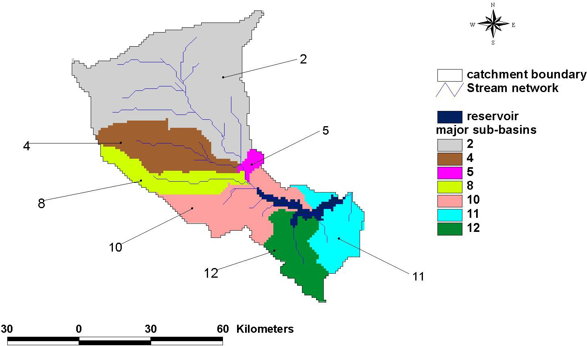
Fig. 2 Discretized sub-catchments as grid layers.

Land-use/land-cover data Many studies have shown that the land uses within a catchment can account for much of the variability in streamwater quantity and quality (e.g. Hunsaker et al., 1992; Roth et al., 1996). The percentage and location of natural land cover influence the amount of energy that is available to move water and materials (Hunsaker & Levine, 1995). For instance, forested catchments dissipate energy asso- ciated with rainfall, whereas catchments with bare ground cover are less able to do so. A drastic change in vegetation cover through clearing and increased agricultural practices without proper conservation measures can produce more runoff (Franklin, 1992).
In this study, a digital land-cover data set for the Masinga catchment was clipped from the land-use/land-cover map of Kenya derived from a twelve-month series of 1-km vegetation index imagery (Loveland & Belward, 1997). This was used because no recent data for the Masinga catchment were available at a finer resolution. The land cover was further classified to reflect the main land-use/land-cover categories in the Masinga catchment. Using the land-use/land-cover in conjunction with soil informa- tion, rainfall incident on each sub-catchment was partitioned to separate surface runoff from water infiltrating into the soil. The land-use/land-cover and soil data were also used in SFM to calculate the response function of each sub-catchment, describing how excess precipitation was routed to the outlet of the sub-catchment.
Soil data The SFM required data describing the average water holding capacity of the soil in (cm), average hydrologically active soil depth in (cm), textural description of the soil class, average saturation soil hydraulic conductivity in (cm h⁻¹), average Soil Conservation Service (SCS) curve number for the soils, maximum and minimum percentage of the impervious catchment area for each sub-catchment. These parameters were extracted from the Digital Soil Map of Kenya (FAO-UNESCO, 1998) by clipping the study area. The main average physical properties for the discretized sub-catchments and some of these parameters are summarized in Table 1.

Table 1 Main average attributes of the discretized sub-catchments.

Basin ID | Soil WHC  (mm) | Soil depth (cm) | Area (km²) | Hlength (m) | Hslope (m) | UpArea (km²) | Elevation (m) | SCS  curve number | Max cover | Manning coeff.
2 | 117.0 | 94.0 | 2758 | 21776.3 | 1.6912 | 2757 | 2143.9 | 76.4 | 0 | 0.065
4 | 127.0 | 101.0 | 821 | 23002.3 | 1.9787 | 820 | 1897.4 | 73.3 | 0 | 0.045
5 | 64.0 | 103.0 | 76 | 5312.6 | 0.6324 | 3654 | 1198 | 79.8 | 0 | 0.025
8 | 108.0 | 98.0 | 506 | 34384 | 1.865 | 505 | 1802.5 | 73.1 | 0 | 0.035
10 | 78.0 | 122.0 | 918 | 16939.1 | 0.901 | 5078 | 1309.9 | 76.9 | 0.00106 | 0.035
11 | 113.0 | 195.0 | 597 | 13419.6 | 0.874 | 6261 | 1121 | 73.9 | 0.00147 | 0.075
12 | 89.0 | 150.0 | 586 | 18397.8 | 0.9661 | 585 | 1213.9 | 75.4 | 0.00106 | 0.055
WHC: water holding capacity; Hlength: hillslope length; Hslope: hillslope (m/100m); UpArea: upslope contributing area; Max cover: maximum % cover of land that is impervious

Table 2 SCS curve numbers in relation to land cover classes and hydrological soil groups. Land cover description Hydrological soil group:
 | A | B | C | D
Urban and built-up land | 73 | 82 | 88 | 90
Dryland cropland and pasture | 71 | 80 | 86 | 86
Irrigated cropland and pasture | 64 | 74 | 81 | 84
Cropland/grassland mosaic | 63 | 73 | 82 | 87
Cropland/woodland mosaic | 51 | 68 | 78 | 82
Grassland | 60 | 76 | 81 | 89
Shrubland | 48 | 62 | 73 | 78
Savanna | 44 | 65 | 77 | 82
Deciduous broadleaf forest | 55 | 66 | 74 | 79
Evergreen broadleaf forest | 55 | 66 | 74 | 79
Water bodies | 100 | 100 | 100 | 100
Herbaceous wetland | 100 | 100 | 100 | 100
Wooded wetland | 100 | 100 | 100 | 100
Barren or sparsely vegetated | 75 | 80 | 85 | 90

In this study, the spatial SCS curve numbers were determined by first merging the hydrological soil groups and land-use/land-cover shape files to form a common field. The ArcView “field calculator” was then used to estimate the curve numbers based on the relationship between the SCS curve numbers, the four hydrological soils groups, and land-use/land-cover given in Table 2.
Rainfall and potential evapotranspiration estimates Daily variations in weather drive the calculation of the streamflow estimates. Fluxes of water between the atmosphere and the Earth’s surface are described using geospatial estimates of preci- pitation and evaporation. A number of methods can be used to estimate rainfall and evapotranspiration. For instance, the rainfall can either be estimated using the satellite rainfall estimates (RFE) or station data. The RFE describe the spatial distribution of precipitation, which the SFM can use to determine the gross input of water to each sub-catchment for each day.
In this study, data from geo-referenced weather stations within the Masinga catchment (Fig. 3) were used. The rainfall and evaporation data for these stations were obtained from the Meteorological Department in Kenya. The daily rainfall and

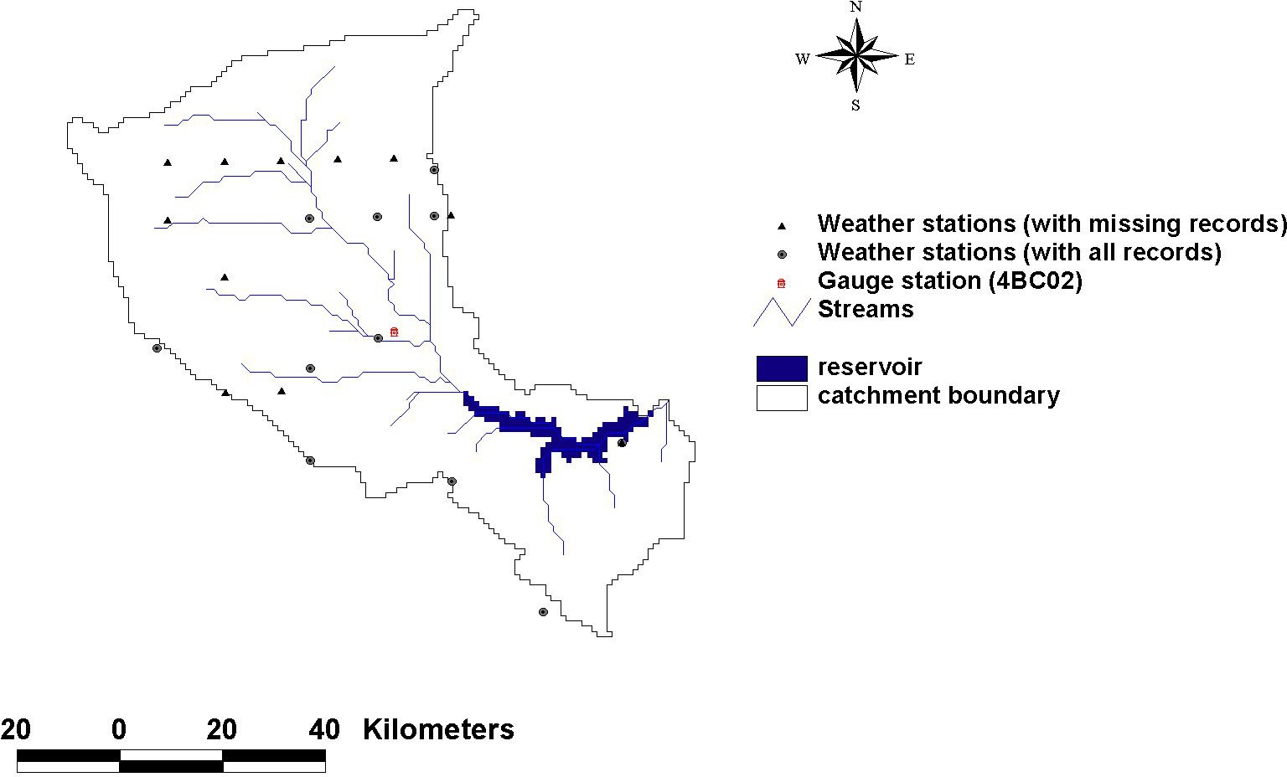
Fig. 3 Delineated catchment showing the stream network, rainfall stations and gauging station.

evaporation were interpolated using the inverse distance weighting (IDW) method and the spatial grids were generated into rain.txt and evap.txt files, a format used by the SFM. These text files together with the basin.txt file derived earlier from the DEM were used as the input data for the model.

Estimation of runoff grid layer
The surface runoff (excess rainfall) was estimated using the SCS curve number method. This was based on the relationship:
(P − 0.2 S )2

Q = i i
i
for P > 0.2S (1)

Pi + 0.8 Si
where subscript i refers to the ith cell, Qi (mm) is the daily runoff, P_{i} (mm) is the daily
rainfall and S_{i} (mm) is the retention parameter estimated using the relationship:

⎛ 100
⎜
Si = 254 CN
⎞
− 1⎟
(2)

⎝ i ⎠
where CN_{i} is the grid curve number.
The overland flow velocity was estimated using the kinematic wave equation. A modified velocity equation was used based on land-use type and land slope. Values of velocity coefficient α_{i} for each land-use/land-cover type were estimated using values given in Table 3. The velocity was estimated using the relationship:

vi = (α_{i} si 2 ) qi
1
(3)

where v_{i} is the runoff velocity (m s⁻¹), s_{i} (m m⁻¹) is the slope of cell i and q_{i} (m s⁻¹) is the specific runoff rate (i.e. runoff rate per unit cell area).

Table 3 Relationship between land cover description and velocity coefficient.

Land cover description | Velocity coefficient
Unknown land use | 0.0000
Urban and built-up land | 6.3398
Dryland cropland and pasture | 0.4572
Irrigated cropland and pasture | 2.7737
Cropland/grassland mosaic | 0.3962
Cropland/woodland mosaic | 0.3962
Grassland | 0.6401
Shrubland | 0.4572
Savanna | 0.4267
Deciduous broadleaf forest | 0.4267
Evergreen broadleaf forest | 0.2134
Water bodies | 14.1122
Herbaceous wetland | 4.7854
Wooded wetland | 3.1394
Barren or sparsely vegetated | 0.6706
(after Maidment et al., 1996 and McCuen, 1998).

Flow depth
Depth.txt

Fig. 4 Conceptual framework for the Stream Flow Model.
Input data
Basin characteristics
Basin.txt
Output
Stream flow data
Streamflow.txt
Stream Flow Model
(SFM)
Soil water data
Soilwater.txt
Rainfall data
Rain.txt
Evaporation data
Evap.txt
Sub-basin response
Response.txt

Running the Stream Flow Model (SFM)
The conceptual framework of the SFM model is given in Fig. 4. After the required grids were created, they were generated into text files (.txt), a format used in the SFM. The most important text files were the basin.txt, response.txt, rain.txt and evap.txt. The SFM graphical user interface (GUI) has a menu from which different functions can be selected. Using the SFM menu, a number of outputs were simulated, some of which included the daily streamflow and the soil water conditions for the discretized sub- catchment as given in Fig. 5.

Stream Flow Model verification
The SFM performance was verified using the observed and simulated daily streamflow data for 1992 at Tana-Sagana gauging station (number 4BC02) (see Fig. 3). The year 1992 was chosen because of the availability of daily rainfall and evaporation records for the whole year for all weather stations considered in the study area. The Tana- Sagana gauging station was chosen because it is the only gauging station with complete daily streamflow records for 1992.

RESULTS AND DISCUSSION
The model was able to simulate streamflow and soil moisture conditions as an indi- cator of the hydrological conditions existing within each sub-catchment. The results in Fig. 5 show the variation of daily streamflow and soil water conditions within each sub-catchment. These results were modelled from the land-use and climatic conditions for 1997. From Fig. 5, it can be seen that daily streamflow and soil water conditions vary significantly across the sub-catchments. This can be attributed to the varied land- use practices, soil characteristics and the agro-climatic zone for each sub-catchment.
The model performance was verified by comparing the observed and simulated streamflow data for Tana-Sagana gauging station (4BC02), as shown in Fig. 6. From the results, it can be seen that the simulated and observed daily streamflow data compare fairly well. The predicted model results give a similar trend of the observed daily streamflow. The flows are highest during April and May. This coincides with the highest rainfall period. Moderately high flows are also recorded during November and December, the period of low rainfall. The model slightly overpredicted daily streamflow during the high rainfall season and underestimated the flows during the low rainfall season. However, from the results (Fig. 6), it can be seen that the model can be used to estimate the daily streamflow.
A statistical criterion for evaluating hydrological goodness of fit between the measured (observed) and predicted (simulated) values was applied. The results were compared using the coefficient of model efficiency (COE) according to Nash & Sutcliffe (1970), given as:
⎛ n 2 ⎞
⎜ ∑(qi − qs ) ⎟

COE
= 1 − ⎜ i ⎟
(4)

⎜ _{n} 2 ⎟
⎜ ∑(qi − qm ) ⎟
⎝ i ⎠
where COE is the coefficient of efficiency, q_{i} is the observed (measured) daily streamflow (m³ s⁻¹), q_{s} is the simulated (predicted) daily streamflow (m³ s⁻¹), n is the number of observations and q_{m} is the mean observed daily flow (m³ s⁻¹). From the results, a COE of 0.74 was obtained. The best coefficient value should be about 1.0 and the value of 0.74 shows that the simulated and observed flows have a moderate correlation and hence the model can be relied upon.
It should be noted that most of the grid layers used as the input data to the SFM to simulate the daily flows were of coarse resolution and this, of course, compromised the model performance. In addition to coarse input data, these results are based on the

150
140
130
120
daily stream flow (cms)
110
100
90
80
70
60
50
40
30
20
10
0

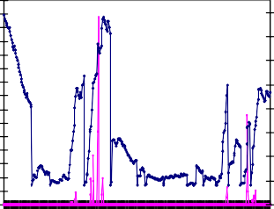
1 31 61 91 121151 181 211241 271301 331 361
days

Sub-catchment 2

210
190
170
150
130
110
90
70
50
60

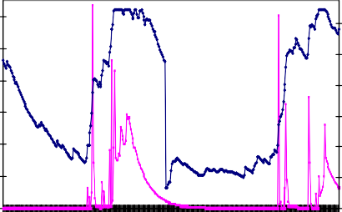
50
daily stream flow (cms)

40
soil water (mm)

30

20

10

0
1 31 61
91 121 151 181 211 241 271 301 331 361


days
daily stream flow soil water

Sub-catchment 4

290

250
soil water (mm)

210

170

130

90

50

160
140
daily stream flow (cms)
120
100
80
60
40
20
0

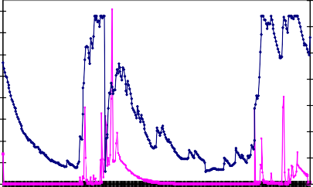
1 25 49 73 97 121 145 169 193 217 241 265 289 313 337 361
days

Sub-catchment 5
170

150

130

110

90

70

50

30

100

80
soil water (mm)
daily stream flow (cms)

60

40

20

0

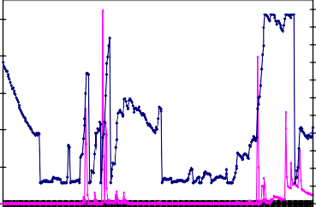
1 25 49 73 97 121 145 169 193 217 241 265 289 313 337 361
days

260
240
220
200
soil water (mm)
180
160
140
120
100
80
60
40

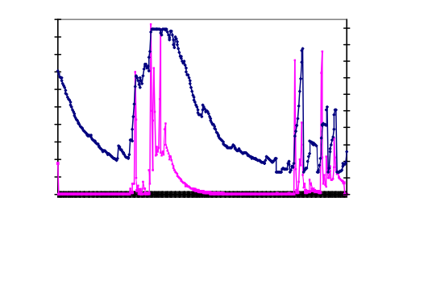
200
200
180
160
140
120
100
80
60
40
20
0
230
210
190
170
150
130
110
90
70
50
30
1 26 51 76 101 126 151 176 201 226 251 276 301 326 351
days

Sub-catchment 10
180
daily stream flow (cms)
160
daily stream flow (cms)
140
soil water (mm)
120
100
80
60
40
20
0

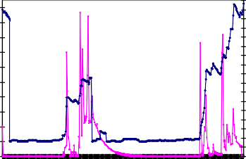
1 31 61 91 121 151 181 211 241 271 301 331 361
days
440
420
400
380
360
340
soil water (mm)
320
300
280
260
240
220
200
180
160
140
120
100

Sub-catchment 11

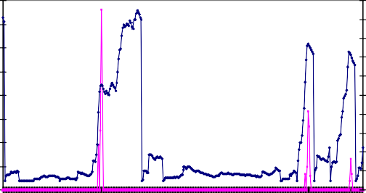
8
7
6
daily stream flow (cms)
5
4
3
2
1
0
1 31 61 91 121 151 181 211 241 271 301 331 361
days
Sub-catchment 12
270
250
230
210
soil water (mm)
190
170
150
130
110
90
70

Fig. 5 Daily streamflow and soil water for the major sub-catchments in the Masinga catchment.

initial model parameters before the model was calibrated. It is envisaged that by varying some of the model parameters, such as the runoff curve number, soil water

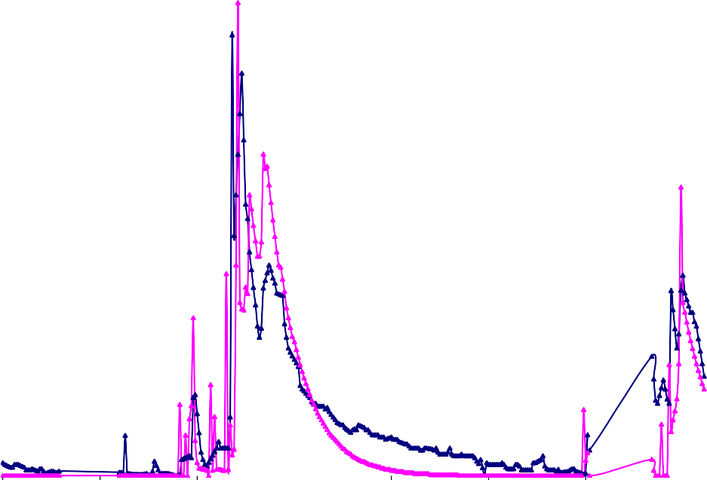
45

40

35

30
daily streamflow (m³/s)

25

20

15

10

5

0
02/01/1992 21/02/1992 11/04/1992 31/05/1992 20/07/1992 08/09/1992 28/10/1992 17/12/1992
observed daily flow
simulated daily flow

day/month/year

Fig. 6 Observed and simulated daily streamflow at Tana-Sagana gauging station (4BC02) in 1992.

holding capacity, soil water depth and the saturated hydraulic conductivity through calibration, the correlation could be significantly improved, thus improving the pre- diction capability of the model.

CONCLUSIONS
This study presents a first attempt in the application of GIS technology to predict daily streamflow in the Masinga catchment. It demonstrates the integration of a physically- based hydrological model, the SFM, within the ArcView GIS environment to estimate daily streamflow for ungauged river reaches in a large rural catchment. The GIS was used to prepare the required spatial data, extract input parameters for the model, execute the model computations, query and display results. The GIS therefore provided a fast and efficient means of generating the input data required for the model. With the availability of remotely sensed data, global and local data sets, the tool can be used by government agencies and catchment stakeholders to continuously monitor the daily streamflow within the catchment.
The results from the preliminary application presented in this paper show a promising alternative method for predicting daily streamflow in ungauged catchments. However, there is a need for more field work to collect data for the model calibration and validation. It is envisaged that the capability of the model to predict daily streamflow will be improved once it is calibrated and validated.

Acknowledgements The authors are grateful to ÖAD (Austrian Exchange Service) for the financial support to carry out this study.

REFERENCES
Bras, R. L. (1990) Hydrology: An Introduction to Hydrologic Science. Addison-Wesley, Reading, Massachusetts, USA. Burrough, P. A. & McDonell, R. A. (1998) Principles of Geographical Information Systems. Oxford University Press,
Oxford, UK.
Cunge, J. A. (1969) On the subject of a flood propagation computation method (Muskingum Method). J. Hydraul. Res. 7, 205–230.
Dooge, J. C. I., Strupczewski, W. G. & Napiorkowski, J. J. (1982) Hydrodynamic derivation of storage parameters for Muskingum model. J. Hydrol. 54, 371–387.
ESRI (Environmental Systems Research Institute) (1996) Cell based modeling with GRID. ESRI Inc., Redlands, California, USA.
FAO-UNESCO (1998) Soil Map of the World, Revised Legend. FAO World Soil Resources Report no. 60. Food and Agricultural Organization of the United Nations, UNESCO, Rome, Italy.
Feaster, T. D. & Tasker, G. D. (2002) Techniques for estimating the magnitude and frequency of floods in rural basins of South Carolina, 1999. US Geol. Survey Water-Resources Investigations Report 02-4140, 5-11.
Franklin, J. F. (1992) Scientific basis for new perspectives in forests and streams. In: Watershed Management (ed. by R. J. Naiman), 25–72. Springer-Verlag, New York, USA.
Gumbricht, T., Lindholm, H., Akre, A., Szczepanek, R., Hessling, M. & McCarthy, J. (1997) GIS integrated modelling of a Himalayan landscape. Int. J. Water Resour. Development 13(1), 14–23.
He, C. (2003) Integration of GIS and simulation model for watershed management. Environ. Modeling and Software.
18(8/9), 809–813.
Hunsaker, C. T. & Levine, D. A. (1995) Hierarchical approaches to the study of water quality in rivers. BioScience 45, 193–203.
Hunsaker, C. T., Levine, D. A., Timmins, S. P., Jackson, B. L. & O’Neill, R. V. (1992) Landscape characterization for assessing regional water quality. In: Ecological Indicators (ed. by D. H. McKenzie, D. E. Hyatt & V. J. McDonald), 997–1006. Elsevier Appl. Sci., New York, USA.
Loveland, T. R. & Belward, A. S. (1997) The IGBP-DIS global 1 km land cover data set, Discover: first result. Int. J. Remote Sens.18, 3289–3296.
Maidment, D. R. (1996) GIS and hydrologic models of non-point source pollution in subsurface water. In: Soil Science Society of America, Special Publ. 48, 163–174.
Maidment, D. R., Olivera, J. F., Calver, A., Eatherral, A. & Fraczek, W. (1996) A unit hydrograph derived from a spatially distributed velocity field. Hydrol. Processes 10(6), 831–844.
Mark, D., Dozier, J. & Frew, J. (1984) Automated basin delineation from digital elevation data. GeoProcessing 2, 299– 311.
Martz, L. W. & Garbrecht, J. (1993) Automated extraction of drainage network and watershed data from digital elevation models. Water Resour. Bull. AWRA 29(6), 901–908.
McCuen, R. H. (1998) Hydrologic Analysis and Design. Prentice-Hall, Upper Saddle River, New Jersey, USA.
Moore, I. D., Grayson, R. B. & Ladson, A. R. (1994) Digital terrain modelling: a review of hydrological, geomorphological, and biological applications. In: Terrain Analysis and Distributed Modelling in Hydrology (ed. by K. J. Beven & I. D. Moore), 7–34. John Wiley & Sons, Chichester, UK.
Nandakumar, N. & Mein, R. G. (1997) Uncertainty in rainfall-runoff model simulations and the implications for predicting the hydrological effects of land-use change. J. Hydrol. 192 (1/4), 211–232.
Nash, J. E. & Sutcliffe, J. V. (1970) River flow forecasting through conceptual models, Part I: A discussion of principles.
J. Hydrol. 10, 282–290.
Niehoff, D., Fritsch, U. & Bronstert, A. (2002) Land-use impact on storm-runoff generation: scenarios of land-use changes and simulation of hydrological response in a meso-scale catchment in SW-Germany. J. Hydrol. 267, 80–93.
O’Callaghan, J. F. & Mark, D. M. (1984) The extraction of drainage networks from digital elevation data. Computer Vision, Graphics and Image Processing 28, 323–344.
Roth, N. E., Allan, J. D. & Erickson, D. L. (1996) Landscape influences on stream biotic integrity assessed at multiple scales. Lands Ecol. 11, 141–156.
Saenyi, W. W. (2002) Sediment management in Masinga Reservoir, Kenya. PhD Thesis, University of Agricultural Sciences (Boku), Vienna, Austria.
Scott, A. O., Gary, D. T. & Graig, M. J. (2003) A geographic information tool to solve regression equations and estimate flow-frequency characteristics of Vermont streams. US Geol. Survey. Open-File Report 02-494.
Wilson, E. M. (1990) Engineering Hydrology, 110, 196, and 301. Macmillan, Indianapolis, Indiana, USA.
Ye, Z. (1996) Map-based surface and subsurface flow simulation models: An object-oriented and GIS approach. PhD Dissertation, University of Texas, Austin, Texas, USA.

Received 12 May 2005; accepted 18 December 2006

