Pervasiveness of green ICT awareness amongst Kenyan ICT personnel
Mr. Franklin Wabwoba¹, Dr. Gregory W. Wanyembi², Dr. Stanley Omuterema³, and Mr. Stephen Makau Mutua⁴
¹Department of Information Technology, Kibabii University College, Kenya

^{2,} ^{3,} ⁴ Department of Computer Science, Masinde Muliro University of Science and Technology, Kenya

ABSTRACT
There has been growing concerns about the rising costs of doing business and environmental degradation world over. Green ICT has been proposed to provide solutions to the two issues yet it is not being implemented fully in developing nations like Kenya despite the availability of the technologies of doing it. The study investigated pervasiveness of green ICT awareness amongst the ICT personnel, how they perceive it to be relevant to their organisations and the drivers towards implementation of the same. The study surveyed ICT personnel in four cases using a questionnaire on a seven scale likert scale. The study established that awareness level of green ICT in Kenya is low when compared with developed nations. It also established the green ICT drivers and how ICT personnel perceived it to be relevant to their organisations. The study recommends the raising of green ICT awareness levels through aligning the ICT personnel’s capacities.
Key words: Green ICT, green ICT awareness, green ICT drivers, relevance of green ICT, Kenya

- INTRODUCTION
Information and communication technology (ICT) is permeating all sectors of the economy and everywhere in the world. This has led to increased uptake of ICT technologies ([1]) that has brought forth challenges to the ICT personnel managing them. This has been complicated with the high rate at which the technologies are changing more so for developing nations like Kenya. ICT professionals are expected to play significant roles in bringing Green ICT to organizations, provided they are prepared, have developed or developing necessary capabilities to lead and support sustainability initiatives ([2]). Such prepared personnel would always be aware of what it is, and how it is to be implemented to achieve its objective.
Use of information and communication technologies promises a lot of gains to business settings however it is not without its side effects especially, the environmental impact. ICT has both positive and negative impact in its use and production. It can also be used to realise reduction of emission of green house gases that have strong negative impact on the climate in the business chain system. In order for ICT to be applied to minimise its negative impact and maximize its positive impact in manner that ensure achievement of sustainable resource utilization, the ICT personnel have to be aware of and how to employ ICT sustainably. To achieve sustainability green ICT has emerged to be used in reducing the direct environmental impact of designing, manufacturing, using and disposing of computer, servers and associated sub-systems ([3]).
This study sought to understand how Kenya ICT personnel perceived relevance of green ICT to their organisation and the pervasiveness of awareness of the same. The study also sought to find out what the personnel thought were the likely drivers of green ICT uptake by their organisation. This would help to understand how the ICT personnel capacity is prepared for implementation of green ICT. It would inform policy makers in the development of the policy based on the level of awareness of the personnel on green ICT.

- GREEN ICT
The rising costs of doing business in an ICT environment and stronger international commitment to reduce greenhouse gas emissions (GHG) and achieve other environmental goals is bound to create pressure to find ways of achieving greater efficient use of energy and other resources while sustaining economic growth ([4]). Green ICT has been used to have the ability to attain the sustainability. It has been known with different names amongst different people and places hence leading to a lack of standard agreed upon definition. Some perceive it to be green IT while other called green computing and still others refer to it as green information systems ([1]). It's important for people to understand what Green ICT is, for businesses to engage with it, and for our decision makers to be aware of its consequences and potential in helping us get to a sustainable world ([5]). Unfortunately there is disparity in the level of green ICT

understanding, causing confusion within the human personnel ([6]). This lack of completely agreed upon definition makes it difficult to measure the effectiveness or the extent of an organisation’s implementation of Green ICT ([5]). Hence, many do not know how or where to begin and are unwilling to implement it ([1]; [6]; [5]).
Green computing according to Hart (1997) [7] is the study and practice of using computing resources efficiently. Green IT is said to be the optimal use of ICT for managing the environmental sustainability of enterprise, its operations, products, services and resources ([8]). From this perspective then it is a process that focuses on strategic deployment of operations and ICT to dynamically, sustainably and responsibly align business goals with green objectives. Unfortunately this approach from the business point of view of saving costs reduces green ICT to energy and cost efficiency that makes it to be undertaken in terms of hardware equipment utilization rather than organizational impact of ICT while pursuing green ICT. This is supported by the Forrester (2009) [9] survey whose findings indicated that the top one motivation for adopting green ICT practices was to reduce costs. From this points of view then green ICT towards sustainability then maybe said to have become a significant issue in the narrow sense while less attention has been paid in the broad view ([4]).
Taken from the broad-view, green ICT involves business innovative practices that enhance the recognition of organizational situations ([10]) and a company’s adaptation to the external dynamics with the use of IT ([11]), and ICT organizational impact where ICT supports business and vice versa ([4]; [2]). It entails applications of environment friendly IT activities with business oriented organizational goals while creating a functional bridge between corporate motivations and environment to attain mutually satisfactory benefits ([12]). It takes in to consideration the ICT personnel capacity for it. Green IT is used for overlapping concepts such as virtualization, recycling, telecommuting, hardware right sizing, energy efficiency and power management among others. The aspiration of Green IT is focused on achieving higher energy efficiency in the use of IT devices and to increase the utilization of already installed devices like servers in data centers. It is a way towards more environment friendly and cost-effective use of power and production technology ([1]). A broad definition needs to take into account the challenge within the ICT personnel capacity in implementing the latest emerging technologies such as virtualization that can be used to achieve energy efficient data centers through the provision of different solutions like live migration, server consolidation, data de- duplications, energy efficiency measurements and green metrics to overcome ICT inefficiencies ([13]). Server consolidation helps in implementing green data centers to ensure that IT infrastructure hardly contributes to the emission of green house gases while at the same time helping to regain power and cooling capacity, recapturing resilience and dramatically reducing energy costs and total cost of ownership ([14]).
For the purpose of this study green ICT will be considered to be the systematic application of ecological-sustainability criteria to the design, production, sourcing, use and disposal of ICT technical infrastructure as well as within the ICT personnel in order to reduce ICT, business process and supply chain related emissions, waste and water use; improving efficiency and generate green economic rent.
The greatest benefit of green ICT to the universe and any nation is the reduced environmental impact and to individual as well as business is cost savings ([15]). This is to be seen against the background of energy consumption in developing countries. ICTs will be pervasive in the government and across industry in order to meet the 2030 vision.
The value of green ICT to the society and companies is so great and is best summarized by table 1.
Table 1: Environmental and companies green ICT benefits
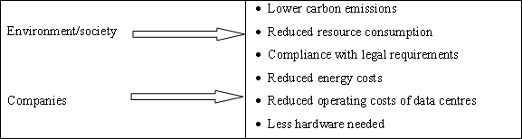

Source: Herman H., Shalaby B. R., Bundgen R., 2010
The value of green ICT can also be group according to capital market level, employees’ level, customer level as well as public citizenry level is summarized in table 2 below.

Table 2: Employees, capital market, customers and the public benefit from Green ICT

Employees | Capital market | Customers | Public
- Increased employee satisfaction  - Greater loyalty  - Easier recruitment | - Improved ratings  - Higher share price  - Greater company value | - Greater customer loyalty  - Appeal to new customer groups  - Greater customer  satisfaction | - Improved image  - Rounded-out CSR strategy  - Greater brand value
Source: Herman H., Shalaby B. R., Bundgen R., 2010
Hardly anything that has benefits lacks its other side. Green ICT has also its disadvantages. This are inclusive of costs need to train personnel, acquisition of new hardware and software to implement green ICT. Green ICT policies may in some cases limit the organisation’s strategic alternatives. Employment of new approaches is likely to introduce newer security risks. One such fear according to Hardof (2009) [16], green ICTs such as virtualisation and cloud computing have security impact since conventional security controls cannot spot malicious traffic passing between virtual hardware. In cloud computing, one cannot tell the country within which the cloud is and hence may not understand which laws to apply on the data to be stored.

- ROLE OF AWARENESS OF TECHNOLOGY
Green ICT starts with ICT personnel’s awareness ([17]). Awareness among ICT personnel plays a significant role in the deployment and implementation of green ICT ([18]). Awareness has an effect on perceived usefulness and perceived ease of use of technologies that have been found in technology adoption theories such as the innovation diffusion theory (IDT), social cognitive theory (SGT), theory of reasoned action (TRA), theory of planned behaviour (TPB), decomposed theory of planned behaviour (DTPB), technology acceptance model (TAM), technology acceptance model 2 (TAM2), combined TAM and TPB (C-TAM-TAB) and unified theory of acceptance and use of technology (UTAUT). People naturally commit themselves on activities and tasks they have an idea about. It has been noted that in countries where environmental education has been included into the education curriculum at all levels like America have seen the same people who have gone through it embracing pro-environmental attitudes ([19]). This is a clear point that when people are made aware green ICT they are more likely to implement it. According to Hamid, Ghafoor & Shah (2012) [19], a gradual increase in people’s awareness in the developed world has created a relatively cleaner environment in comparison to the developing countries ([19]). Lack of awareness has been reported to hinder application of technology ([20]). Lack of technology awareness often results in organizations failure to seek opportunities that can be achieved with its adoption and implementation ([21]). The decision to invest in, adopt and implement green ICT will be difficult to arrive at when organizations are unaware of the potential benefits they can derive from such an a undertaking.

- METHOD
The study surveyed four cases that included a leading sugar manufacturing factory in the country that has invested into intensive application of ICT in virtually all its operations, a public university that offers training programs in Information technology starting from certificate all the way to doctoral level, a communications commission involved in the regulatory tasks of information and communications technology in the country and senior government officers at county level. Within the four cases respondents were selected based on the involvement in ICT use. They consisted of top management, ICT technical users, postgraduate (MSc and PhD) level students and senior government officers. The postgraduate students consisted of a combination of Information Technology lecturers, ICT managers and ICT technical workers in various companies and government departments in the country. The study used a combination of questionnaires, interviews and observation to collect data. The questionnaire used a seven scale of responses ranging from strongly disagree taking the value of 1 and being the lowermost while strongly agree was the highest with the value 7. The neutral value had been assigned a value of 4. The respondents therefore ranked their level of agreement with provided statements on the scale of seven (1. Strongly disagree 2. Disagree 3. Fairly disagree 4. Neutral 5. Fairly agree 6. Agree 7. Strongly agree).

- FINDINGS OF THE STUDY
The first aspect examined was the perceived value of green ICT to their organisation. From technology adoption theories and studies it has been observed that ICT tends to be adopted and hence implemented more when the users perceive it to be useful to them and the organisation. It’s most likely that green ICT will be implemented if the ICT

personnel perceive it to be of use to them and the organisation. The findings of the study on how the respondents thought of the value of green ICT to their organisations are presented in table 3.
Table 3: Relevance of green ICT
Green ICT relevance variable | Mean | Std. Deviation
Reducing the costs of powering ICT infrastructure | 3.10 | 1.114
Purchasing more environmentally friendly ICT technology | 2.44 | 1.340
Use of ICT to minimise carbon emitting business practices | 2.95 | 1.126
Discarding ICT items in an environmentally friendly manner | 4.66 | .915
Improving energy efficiency of data centres | 4.07 | .930
Reducing the costs of running data centres | 4.19 | .779
Reducing ICT's contribution to green house gas emissions | 3.13 | 1.322
Complying with green regulatory requirements | 2.73 | .873
The respondents’ highest mean was obtained on green ICT being of value in terms of discarding ICT items in an environmentally friendly manner that was 4.66 with a standard deviation of 0.915. This was followed by reducing cost of running data centres with a mean of 4.19 and standard deviation of 0.779. In the third position was improving efficiency of data centres with a mean of 4.07 and a deviation of 0.930. This was followed by reducing ICT’s contribution to green house gas emissions whose mean was 3.13 having a standard deviation of 1.322. The firth green ICT relevance item had a mean of 3.10 with a standard deviation of 1.114 that was closely followed by use of ICT to minimise carbon emitting business practices that had 2.95 for mean and 1.126 for standard deviation. The third last was complying with green regulatory requirements having a mean of 2.73 and a standard deviation of 0.873. The second last with a mean of 2.44 and standard deviation of 1.34 was purchasing more environmentally friendly ICT technology. The least was purchasing more environmentally friendly ICT technology having a mean of 2.44 with a standard deviation of 1.340.
The second aspect that the study sought to understand was the drivers of green ICT as perceived by ICT personnel to be the most likely to propel it. The findings are presented in table 4

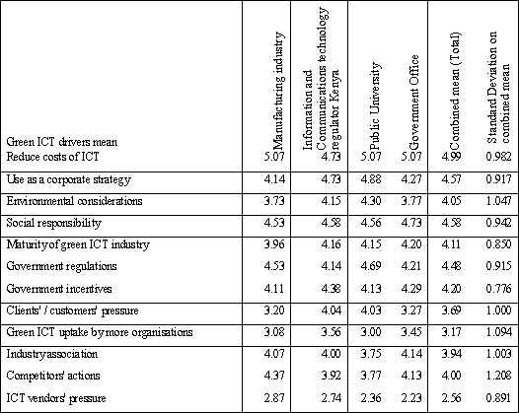
Table 4: Drivers of green ICT

The perception of the ICT personnel with regard to the drivers of green ICT is similar in all the four cases. From the findings, the respondents believe that the driver of reduction of costs is topmost in pushing for adoption and implementation of green ICT having the mean response of 4.991 and a standard deviation of 0.982. Second to it is the driver of social responsibility having a mean of 4.582 and a standard deviation of 0.942. This is followed by the use of green ICT as a corporate strategy whose mean response is 4.571 with a standard deviation of 0.917. In the fourth position is government regulations drive whose mean is 4.477 and a standard deviation of 0.915. The next drive in the influence of green ICT implementation was found to be Government incentives whose mean was 4.20 with a standard deviation of 0.776. The maturity of green ICT industry drive had then a mean of 4.112 with a deviation of 0.85. Maturity of the industry was followed by environmental considerations whose mean was 4.054 and a standard deviation of 1.047. The driver that had a mean of 4.000 was the competitor’s actions in green ICT and had a standard deviation of 1.208. The fourth last driver was industry association with a mean of 3.937 and a standard deviation of 1.003 that was followed by clients’ /customers’ pressure towards implementing green ICT whose mean was 3.694 and standard deviation of 1.000. The last drivers that had means of less than four were green ICT uptake by more organisations with a mean of 3.173 and a standard deviation of 1.094 and pressure of vendors of the technology that had a mean of and
2.559 standard deviation of 0.891
The third aspect examined was the pervasiveness of green ICT awareness within the organisation. According to Mariani &Imam (2012) [18] awareness of green ICT among ICT personnel plays a leading role in the deployment of its initiatives. The pervasiveness did measure the extent to which they ICT personnel and organisations were concerned about E-waste management, ICT’s energy consumption, efficiency of cooling and lighting data centres, overall environmental footprint, ICT’s contribution to greenhouse gas emissions, ICT suppliers’ environmental footprint, regulations in green house gas emissions, clients’ environmental footprint, provision of budget and other resources earmarked for green ICT is done and whether top management discussed green ICT issues as a priority. The items appear to be perceived at the same levels in all the four cases based on the mean findings from the respondents as can be observed from the findings in table 5.
Table 5: Results on pervasiveness of green ICT awareness

 | m anufacturing Industry | Information and Communications technology regulator | Public University | Government Office | Com bined mean (Total) | Standard deviation on total
E-waste management | 5.25 | 5.46 | 5.5 | 5.4 | 5.40 | 0.785
ICT's energy consumption | 4.07 | 4.21 | 3.8 | 3.9 | 3.96 | 1.096
Efficiency of cooling and lighting data centre | 5.41 | 5.12 | 4.4 | 4.7 | 4.86 | 1.008
Overall environmental footprint | 4.13 | 3.31 | 3.6 | 3.9 | 3.73 | 1.319
ICT's contribution to green house gas emissions | 3.43 | 3.46 | 2.9 | 3.9 | 3.30 | 1.413
ICT suppliers' environmental footprint | 2.79 | 2.61 | 2.5 | 2.4 | 2.60 | 1.033
Regulations in green house gas emissions | 2.77 | 2.5 | 1.8 | 2.8 | 2.34 | 0.961
Clients' environmental footprint | 1.55 | 2.15 | 2.2 | 1.6 | 1.94 | 0.931
Provision of budget and other resources for green ICT | 1.89 | 2.35 | 1.8 | 1.5 | 1.90 | 0.830
Top management discusses green ICT as a priority | 3.39 | 3.69 | 1.8 | 3.1 | 2.81 | 1.395

E-waste tops the list of highest level of concern in the Information and Communications Technology regulator sector, the public university sector and Government office while it takes the second position in the manufacturing industry. This is closely followed by concern on the efficiency of cooling and lighting of data centres where it is second Information and Communications Technology regulator sector, the public university sector and Government office while it takes the first position in the manufacturing industry. In all the four sectors the concern over ICTs energy consumption takes the third position. The concern over the overall footprint comes next being at sixth position in Information and Communications Technology regulator sector, fourth position the public university sector, third position Government office while it takes the fourth position in the manufacturing industry. In the firth position was concern over ICT’s contribution to green house gas emissions in all sectors except Government office where it was sharing with other two items at the third position. Next was top managements discussion of green ICT matters as a priority that was position four in the Information and Communications Technology regulator sector, position six in the public university sector, position six in the Government office while taking the fourth position in the manufacturing industry. Coming in next was the organisations concern about the ICT supplier’s environmental footprint being at position seven in Information and Communications Technology regulator sector, position six at the public university sector, position eight at the Government office and seventh position in the manufacturing industry. Next was the concern over regulations in green house gas emissions where it was in the eighth position in all except in the government office where it takes the seventh position. Concern over client’s environmental footprint was at last position in the Information and Communications Technology regulator sector and the manufacturing industry, seventh position at the public university sector and ninth position Government office. Finally, was provision of budget and other resources for green ICT where it was in the ninth position in the Information and Communications Technology regulator sector and manufacturing industry, eighth position in the public university sector and last or tenth position in the Government office sector.

- DISCUSSION AND INTERPRETATION OF THE FINDINGS
The findings presented graphically for the perceived value of green ICT to organisations is presented in Figure 1.
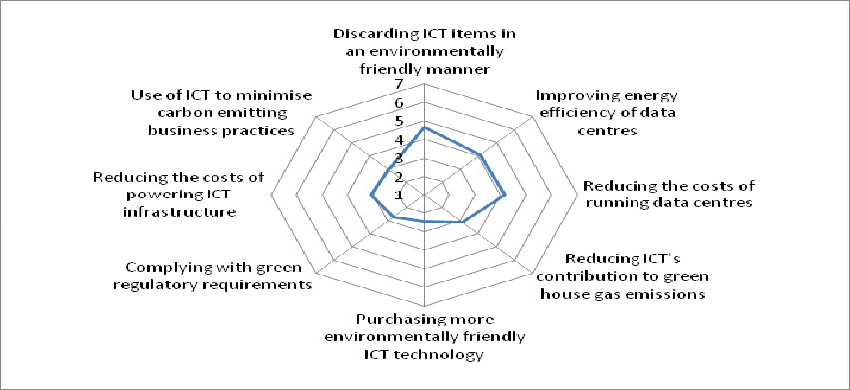

Figure 1: Value of green ICT to organizations
People are most likely to adopted and implement a technology if they believe that it is of value to them and their organisation. Of the items presented to respondents on the value of ICT, their responses are as given in figure 1. The close the graph is to 1 the less valuable the items is taken to be towards green ICT and the more close it is to 7 the more valuable the item is perceived to be to the organisation. From figure 1, it can be observed that the respondents perceive Discarding ICT items in an environmentally friendly manner to be of the greatest value to green ICT to the organisation. This has a mean of which is close to a 5 value that corresponds to fairly agree. The respondents’ standard deviation being less than 1 suggests how close the responses were for all of them suggesting how definitive the responses were. Secondly ranked was improving energy efficiency of data centres. This implies that in marketing green ICT if used it is likely to have a good portion take on it. The third ranked in perceived value of green ICT was reducing the costs of running data centres. This was followed by reducing the costs of powering ICT infrastructure that was followed by reducing ICT's contribution to green house gas emissions. In general the respondents did not seem to find green ICT to be valuable in using of ICT to minimise carbon emitting business practices or in complying with green regulatory requirements in existence in the country.
They respondents did not find that the least perceived to be valuable to green ICT to be purchasing more environmentally friendly ICT technology. This suggested that either the respondents are not aware of any regulations

within the country on green ICT to be complied with or the regulations are not there all together. People have been known to make effort to compile with regulations where they exist.
Since Kenyan ICT personnel perceive that green ICT is valuable in terms of costs saving and reducing on environmental pollution, they are likely to implemented it if it is presented (marketed) to them according to the two factors. It is also not likely to make any impact towards being implemented if it were to be marketed in terms of complying with any current legislation to be complied with or making friendly purchases of ICT technology.
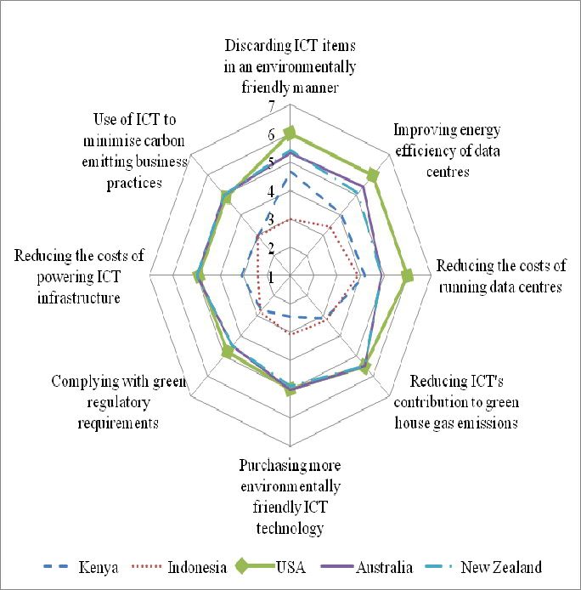
When compared to other nations in world with regard to how they perceived green ICT, Kenyan personnel do not seem to really find it to be very valuable. Kenyans valuing it is below that of how Americans, Australians and New Zealanders perceive it to be. The Kenyans perception is only very slightly better off than that of Indonesians. The comparison of how valuable green ICT is for different nations is provided for in figure 2.
Figure 2: Country comparison of perception of value of green ICT
The perception of how valuable green ICT is perceived seems to tally with the findings of green ICT pervasiveness as given in figure. USA, Australia and New Zealand are above in perceiving green ICT usefulness to be higher than that of Kenya with a big margin. Kenya only draws nearer to the three nations on the value with regard to discarding ICT items in an environmentally friendly manner. This may be due the reliance by Kenyan organisation on acquisition of ICT hardware based on donations [23].
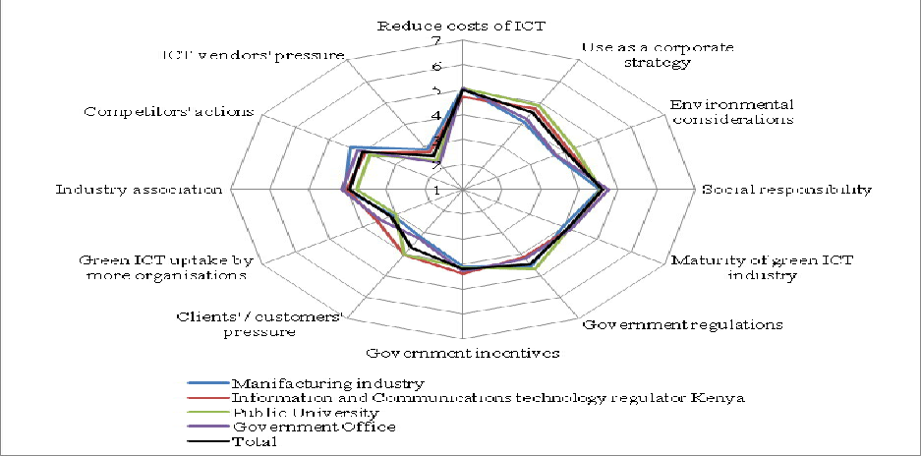
Aside from the perceived value of a given technology in its implementation, the forces in place that drive the adoption of a technology are critical in its implementation as well. The perception of Kenyan ICT personnel on green ICT drivers within the cases may be summarized as given in figure 3
Figure 3: Green ICT drivers’ perceptions within each study case in Kenya
Generally the green ICT pervasiveness level can be said to be very low. The findings indicate that the organisation have no concern over most of the green ICT aspects except for e-waste and efficiency of cooling and lighting of data centres where the means are 5.36 and 4.71 respectively. In the two aspects, the means suggest that the ICT personnel fairly agree to their organisations being concerned about them. The organisations seem to have little concern over the clients’ footprint where the respondent gave an overall mean of 1.58 that corresponds to disagree. On the over all there is little

concern on the suppliers’ environmental footprint, ICT’s contribution to greenhouse gas emissions and regulations in greenhouse gas emissions. The none education organisations seems to be having slightly better awareness of green ICT concept as both of them having the best mean in three items each as compared to two where the education organisation leads. These finding calls for effort to be made to increase the green ICT awareness levels in the universities since this are institutions that may have a greater impact on ICT personnel as they train them. All the same, some of the leading have very low means for the leads to have any significant impact towards green ICT.
The findings on table 5 indicate that budget provision and other resources provision for green ICT is lacking in all the cases as they all recorded means of less than 2.5. No meaningful implementation of green ICT initiatives may take place without resources and finances being set aside for it. From the findings on the same table, it appears that in all cases top management hardly discusses green ICT issues. This is because all of the cases record an average return value of less than 3.7 therefore fairly disagreeing that top management discuss green ICT. Having top management discuss green ICT issues has great impact on implementation because its initiatives start with ICT personnel and leaders positive sentiments towards the same [17].
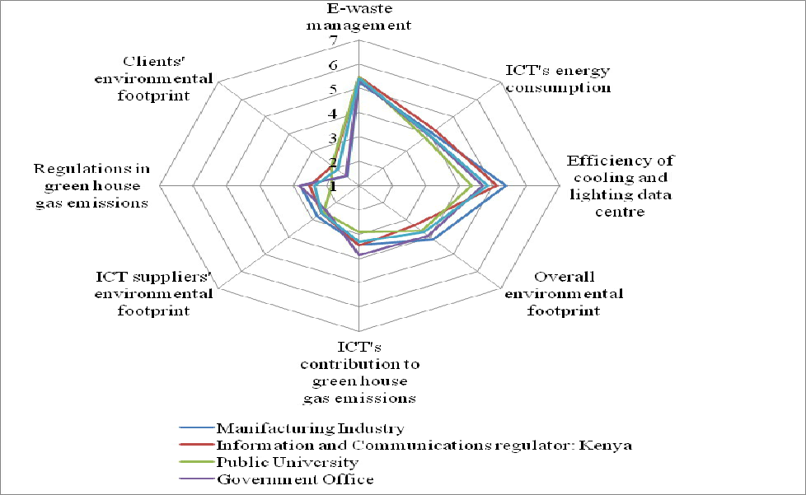
The different organizations in Kenya tend have the same level of green ICT pervasiveness levels as can be seen from the findings presented in figure 4

Figure 4: Graph of pervasiveness of green ICT within organisations
All organization as the results indicates that they are just on the verge of uptake of green ICT. A part from two sections, the rest had mean scores of value of 4 which gives the average. Most of them being below the 4 value suggest low level of awareness of green ICT. This calls for purposed effort to increase the awareness levels of green ICT within the organisations. According to Hamid, Ghafoor & Shah (2012) [19], increase in people’s awareness has made it possible to create a relatively cleaner environment within developed nations. The same established in their study that greater ecological awareness leads to a positive attitude towards green purchase, and conversely, a lesser degree of ecological knowledge leads to indifference or a negative attitude. Positive attitudes towards green ICT will lead to high levels of implementation of the same. It has been known that green ICT naturally starts with ICT personnel’s sentiments towards them same [17]. There is need for a deliberate effort to made to increase the levels of green ICT awareness amongst green ICT personnel since when they are aware about green products, they are more likely to purchase such products and would even be ready to pay some premium for the perceived benefits ([19]). Most consumers in the United States and Europe have professed the usefulness of green products and they exhibit a relatively higher amount of readiness to pay more for such products ([22]). One way of increasing awareness may be through in-cooperating green ICT into academic programs appropriately as per the level of learners and training. Training may be worth using as the study also established that there was some positive relationship between training (academic and technical) and the five variables of green ICT as outlined in table 6.

Table 6: Spearman’s rho correlation coefficients of awareness pervasiveness and demographic variables

 |  | Reducing the costs of powering ICT infrastructure | Purchasing more environmentally friendly ICT technology | Use of ICT to minimise carbon emitting business practices | Discarding ICT items in an environmentally friendly manner | Improving energy efficiency of data centres | Reducing the costs of running data centres | Reducing ICT's contribution to green house gas emissions | complying with green regulatory requirements
Age of  respondent | Correlation  Coefficient | .284  (**) | .281  (**) | .349  (**) | -.180  (*) | .224  (**) | .152 | -.039 | .098
 | Sig. (1-tailed) | .001 | .001 | .000 | .026 | .008 | .052 | .338 | .152
Respondent's  gender | Correlation  Coefficient | -.102 | .002 | .017 | .056 | -.152 | -.027 | .104 | -.043
 | Sig. (1-tailed) | .138 | .490 | .430 | .275 | .051 | .385 | .133 | .326
Highest acad. qualifications | Correlation Coefficient | .025 | .070 | -.225  (**) | -.137 | -.256  (**) | -.330  (**) | .192  (*) | .173(  *)
 | Sig. (1-tailed) | .395 | .226 | .007 | .072 | .003 | .000 | .019 | .035
Highest ICT  qualification | Correlation  Coefficient | .236  (**) | .159  (*) | .117 | -.132 | -.043 | -.114 | .163  (*) | .244  (**)
 | Sig. (1-tailed) | .005 | .044 | .106 | .079 | .323 | .111 | .040 | .005

* Correlation is significant at the 0.05 level (1-tailed). ** Correlation is significant at the 0.01 level (1-tailed).
From the evaluations obtained in table 6, it can be observed that the age of respondents which may be considered to be directly related to ones experience has a significant relationship with the understanding of green ICT relevance awareness factors to an organisation’s business. Based on spearman’s rho coefficient values to the age of respondents, there is a moderate direct relationship at 0.01 (1-tailed) significance level with the understanding on reducing of costs of powering ICT infrastructure (0.284), purchasing more environmentally friendly ICT technology (0.281), use of ICT to minimise carbon emitting business practices (0.349) and improving energy efficiency of data centres (0.224). At the same time it has a weak indirect relationship with discarding ICT items in an environmentally friendly manner of coefficient 0.180 at a significant level of 0.05 (1-tailed). It is also apparent from the evaluations obtained in table 6 that there is no significant relationship with regard to gender and the green ICT awareness variables. Therefore the gender of the respondents has no influence on the awareness level of a given person and hence the organisations.

The highest general academic qualification seems to have a significant relationship with the green ICT awareness. From the spearman’s rho coefficient values obtained the highest general academic qualification of respondents has a moderate indirect relationship at 0.01 (1-tailed) significance level with the use of ICT to minimise carbon emitting business practices (0.225), improving energy efficiency of data centres (0.256), and reducing the costs of running data centres (0.330). At the same time it has a direct weak relationship with reducing ICT's contribution to green house gas emissions (0.192) and complying with green regulatory requirements (0.173).

Lastly, there is a significant relationship between the highest ICT qualification and green ICT awareness factors. According to spearman’s rho coefficient values obtained the highest technical academic qualification of respondents has a indirect relationship at 0.01 (1-tailed) significance level with reducing the costs of powering ICT infrastructure that is moderate (0.236), purchasing more environmentally friendly ICT technology that is weak (0.159), reducing ICT's contribution to green house gas emissions that is weak (0.163) and complying with green regulatory requirements that is moderate at 0.244.

The pervasiveness of green ICT within Kenya as at 2012 in comparison to other countries in the world such as Australia, New Zealand and USA as at 2009 and Indonesia as at early 2012 is as presented by figure 6

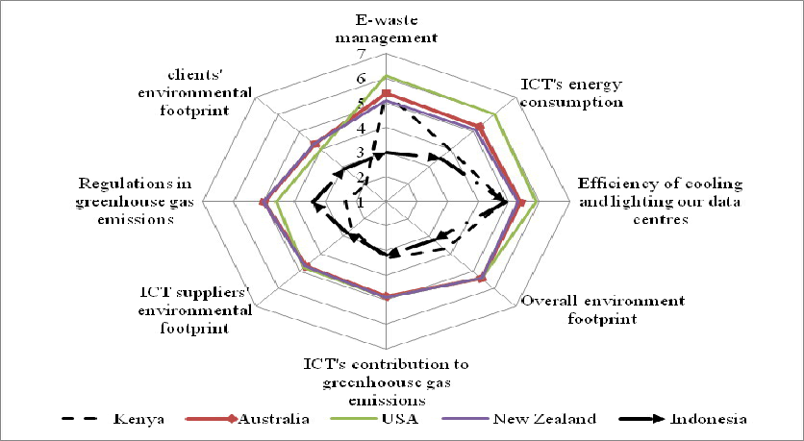

Figure 6: Pervasiveness green ICT awareness an international perspective
From the findings presented in figure 6 indicates that the pervasiveness of green ICT awareness in Kenya is relative same as that of Indonesia except for e-waste concern. Here the country appears to be at the same level with Australia and New Zealand. Otherwise on the rest of the awareness aspects Kenya is fairly below where Australia, USA and New Zealand were in 2009. There is need therefore for policy makers to make deliberate effort to raise the levels and have green ICT implemented. As the country goes out of its way to work towards sustainability in its vision 2030, there is more to technology use than adopting it. It will be prudent to realize that excessive use of technology is not the way for achieving economical and technological development but that use of such sophistication should be coupled with sound planning, having bare minimum adverse effects on the natural environment. Sustainability is critical in ICT use hence the need to implement green ICT.

- CONCLUSION AND RECOMMENDATION
Kenyan ICT personnel perceive green ICT to be fairly relevant to their organisations especially in terms of discarding ICT items in an environmentally friendly manner. At the same time they are aware of the drivers of green ICT likely to drive organisations into implementing it with reducing costs topping the list. Considering the findings of the study, it is apparent that the pervasiveness of green ICT in Kenya has a lot of room for improvement. Comparing the findings of the same in the USA, New Zealand and Australia in 2009 when it is presumed they were at their early stages as Kenya is now then there is a significant short fall in both breadth and depth of green ICT with exception of e-waste management.
There is great need to apply green ICT to improve chances of realising both organisational and ecological sustainability in order for Kenya organisation to contribute towards the realization of the county’s 2030 vision. There is need however to understand how ready the organisations are towards green ICT and how the ICT personnel capabilities may be aligned for the country to realise the benefits of green ICT implementation.

REFERENCES
- Wabwoba F., Wanyembi W. D. & Omuterema S. (2012). Barriers to green ICT implementation in Kenya.
International Journal of Science and Technology. 2(12): 823-836
- Molla A., Cooper V. A., & Pittayachawan S. (2009). IT and eco-sustainability: Developing and validating a green IT readiness model. Thirtieth International Conference on Information Systems, (p. 17).
- Murugesan, S. (2008). Harnessing Green IT: Principles and Practices. IT Professional IEEE computer Society , 10 (1): 24-33.
- Dedrick J. (2010). Green IS: Concepts and issues for information systems research. Information Systems Management 25(2): 159-173
- Philipson G. (2010). A Green ICT Framework: Understanding and Measuring Green ICT. Australia: 2010 Connection Research Services Pty Ltd (ABN 47 092 657 513).
- Murugesan S., & Laplante P. A. (2011). IT for a greener Planet. IT Professional IEEE Computer Society , 13 (1): 16-18
- Hart SL (1997). Beyond Greening: Strategies for a Sustainable World. Harvard Bus. Rev., 75(1): 66-76.

- Mingay S (2007). Green IT: A New Industry Shockwave, Gartner.
- Forrester (2009). IT’s role in reducing corporate environmental impact: A commissioned study conducted on behalf of Cisco systems Inc. http://cisco.com/en/US/prod/collateral/switches/ps5718/CiscoTLP final.pdf
- Ghose A., Hassan H. & Spedding T. (2008). Carbon-centric computing: IT solutions for climate change, University of Wollongong working group on the carbon-centric computing initiative. www.uow.edu.au/~aditya/research/ccci/CCCi
- Haung L. K. (2012). Factors affecting green IT alignment: A contingency perspective. Business and Information. 3-5
- Hanuv M, Grant G, Mann IJS (2009). Green IT: An Implementation Framework. AMCIS 2009 Proceedings.
- Uddin M. & Rahman A. A. (2011). Techniques to implement in green data centres to achieve energy efficiency and reduce global warming effects. International Journal of Global Warm. 3(4): 372–389.
- Uddin M, Talha M, Rahman A. A, Shah A., Khader J. A. & Memon J. (2012) Green Information Technology (IT) framework for energy efficient data centers using virtualization. International Journal of Physical Sciences 7(13): 2052 – 2065
- Herman H., Shalaby B. R., & Bundgen R. (2010). The greeing of Business. Frankfurt: Am Main: International GmgH.
- Murugesan S., & Laplante P. A. (2011). IT for a greener Planet. IT Professional IEEE Computer Society , 13 (1): 16-18.
- Mariani M. & Imam K. (2012). A Preliminary Study of Green IT Readiness in Indonesian Organizations.
Journal of Energy Technologies and Policy , 2 (5): 1-10.
- Hamid S. A. R., Ghafoor H. A. & Shah T. Z. (2012). Analysis of attitude towards green purchase: Pakistan in context. International lournal of business and social science , 3 (6): 112-115.
- Apulu I. & Latham A. (2009). Information and Communication Technology Adoption: Challenges for Nigerian SMEs. TMC Academic Journal, 4(2): 64-80
- Ogunyemi A. A. & Johnston K. A. (2012 (b)). Exploring the roles of people, governance and technology in organizational readiness for emerging technologies. The African Journal of Information Systems , 4 (3): 100-119.
- Oyewole P. (2001). Social costs of environmental justice associated with the practice of green marketing.
Journal of business ethics 29: 239-251
- Munyua, A. W. (2010). Kenya. In A. Finlay, Global Information Society Watch 2010: Focus on ICTs and Environmental Sustainability (pp. 161-163). APC and HIVOS ISBN 92-95049-96-9.

ACKNOWLEDGEMENT
We acknowledge with appreciation the National Council of Science and Technology (Kenya) for funding the research “enhancing GREEN ICT through ICT personnel capacity alignment in developing nations” from which this paper was developed.

AUTHORS

Mr. Franklin Wabwoba is a lecturer at Kibabii University College (Kenya) in the Department of Information Technology. He holds a MSc (Computer Applications) degree from Kenyatta University; Endorsement (Educational Management) from University of South Africa and BEd (science: Mathematics and Computer Science) degree from Egerton University and is pursuing a PhD in Information Technology at Masinde Muliro University of Science and Technology. He has taught Computer Science and Information Technology courses for many years. He has had ICT industrial
experience while working at Mumias Sugar Company. He has presented several papers in scientific conferences and is widely published in referred journals. He has a strong research interest in the impact of ICT applications on the community, integration of ICT into education, and green ICT. He is a professional member of ACM.


Dr. Gregory Wabuke Wanyembi (PhD) obtained his doctorate in management of ICTs from Delft University of Technology, The Netherlands, in 2002. He has published widely in the area of management and strategic utilization of ICTs in developing countries. He is engaged in several research projects and supervision of postgraduate students at both masters and PhD from different universities in Kenya. He is a reviewer of journal articles. He is senior lecturer at Masinde Muliro
University of Science and Technology, Kenya.

Dr. Stanley Omuterema (PhD) obtained his doctorate in Environmental studies from Moi University. He has published widely. He has wide experience having taught in secondary school, Eldoret Polytechnic, and Masinde Muliro University of Science and technology


Mr. Mutua Stephen is a computer science lecturer at Masinde Muliro University of Science and Technology. He has four years teaching experience and his research interests are in Software Visualization, Mobile Computing and Use of Technology in Pedagogy. He is an upcoming scholar who has published widely in various journals. He holds a Master of Science in Information Technology and a B.Sc. in Computer Science (First Class) from Masinde Muliro University. He is a professional member of ACM.

Volume 2, Issue 1, January 2013 Page 104

View publication stats

