

Environmental Nanotechnology, Monitoring & Management 15 (2021) 100429
Contents lists available at ScienceDirect

Environmental Nanotechnology, Monitoring & Management

journal homepage: www.elsevier.com/locate/enmm


Microwave assisted synthesis of oleic acid modified magnetite nanoparticles for benzene adsorption
Makhosazana Masuku ^{a,}*, Linda Ouma ^{b}, Agnes Pholosi ª
ª Department of Chemistry, Vaal University of Technology, Private Bag X021, Vanderbijlpark, 1900, South Africa
^{b} Department of Science, Technology and Engineering, Kibabii University, P. O. Box 1699, Bungoma, 50200, Kenya

A R T I C L E I N F O

Keywords:
Adsorption–desorption cycle Benzene adsorption Industrial wastewater Magnetite-organic acid Volatile organic compound
A B S T R A C T

Benzene is a carcinogenic, mutagenic and highly toxic nonpolar organic compound, its presence in water occurs as a result of leakage of underground pipes and improper effluent disposal. Adsorption techniques have proven to be efficient for benzene removal from water providing a low maintenance method with high removal efficiencies. Nanoparticles provide high surface areas for adsorption and magnetite particles are specifically advantageous owing to their magnetic characteristics. Magnetite surfaces require modification with hydrophobic compounds for the adsorption of nonpolar pollutants. Herein, magnetite nanoparticles (MNP) were modified with oleic acid to form a magnetite-oleic acid composite (MNP-OA) via microwave synthesis for the adsorption of benzene from simulated wastewater. Infrared analysis confirmed the interaction between magnetite and oleic acid and particle diameters were determined by XRD analysis as 19.7 nm and 17.1 nm for MNP and MNP-OA respectively. Magnetic measurements indicated that both materials were superparamagnetic with a decrease in saturation magnetization after modification due to the non-magnetic layer on the surface. Oleic acid modification improved the benzene uptake of magnetite nanoparticles by approximately 30 % while kinetic studies suggested that a concentration driving force controlled the adsorption process. The adsorbent was regenerated and was efficient for five adsorption-desorption cycles.

Introduction

Water is the earth’s most important liquid. Its abundance in nature has led to human civilization and economic development through agricultural use as well as power generation. Although water is an important commodity, it has not gone unnoticed that water scarcity has become a major global challenge. Industries are high water consumers generating high quantities of liquid effluent. One of the most common oil-based pollutants in natural resources is benzene. Benzene is a mono aromatic hydrocarbon mainly used in industry to produce synthetic rubber, polystyrene, and detergents (Parvizi et al., 2020). As a gasoline additive, benzene improves the octane rating and reduces knocking (Hussein and Ahmed, 2016; Russo et al., 2018).
Although benzene compound is used in the industry it is highly toxic and ranked in sixth place on the priority list of dangerous substances. It enters water systems through leakage of petroleum from underground storage tanks, improper disposal of effluent containing benzene, the extraction process, and vehicle exhaust (Alves et al., 2017; Yang et al., 2016). Benzene has negative impacts on both human beings and the
environment. Exposure to between 700 and 3,000 ppm leads to effects such as cancer, brain damage, respiratory and excretory system damage (Khodaei et al., 2017; Salvi et al., 2017). Other health effects include leukaemia, and kidney failure which can be chronic and fatal if not treated (Salvi et al., 2017). As an environmental problem, benzene contributes to the formation of ground-level, global warming, and toxic peroxyacyl nitrates through atmospheric photochemical reactions (Niu et al., 2016). Despite all these health factors reported on the dangers of benzene compounds, many industries worldwide still use it due to the extent of their applications (Vidal et al., 2012). Different studies have been conducted for the removal of benzene from wastewater and gov-ernment authorities have placed very stringent environmental standards for the maximum allowable levels of these organics in water for human consumption. The United States Environmental Protection Agency and the German guideline have established the benzene concentration to be 1 μg L^{—1} in drinking water (Sivasankar and Gopalakrishna, 2017).
Studies show different benzene removal methods such as oxidation, biological treatment, catalysis, membrane separation, and adsorption (Dickhout et al., 2017; Konggidinata et al., 2017; Sheikholeslami et al.,

* Corresponding author.
E-mail address: khosidmasuku@gmail.com (M. Masuku).

https://doi.org/10.1016/j.enmm.2021.100429
Received 13 September 2020; Received in revised form 20 December 2020; Accepted 20 January 2021
Available online 30 January 2021
2215-1532/© 2021 The Authors. Published by Elsevier B.V. This is an open access article under the CC BY license (http://creativecommons.org/licenses/by/4.0/).

2018). A number of these methods have drawbacks such as high capital costs, large production of sludge and high disposal costs (Ali et al., 2018; Bhatnagar et al., 2015). The use of the adsorption technique has proven to be efficient over the years, especially at very low concentrations (Konggidinata et al., 2017; Wang et al., 2018). The technique has a high impact on wastewater treatment in terms of low maintenance, high removal efficiency, ease of operation, regeneration as well as the pro-duction of high-quality treated effluents (Kandisa and Saibaba, 2016; Sophia and Lima, 2018). It is evident from the literature that the success or failure of adsorption separation is mainly dependent on the adsor-bent’s performance in both kinetics and equilibrium studies. Adsorbents such as organoclays, activated carbon, and zeolites, have been efficient for benzene removal, however, they have drawbacks such as high costs, low surface areas, low sorption capacities and regeneration problems (Carvalho et al., 2012; Deng et al., 2020). To overcome the limitations of these adsorbents for benzene removal, surface modification to improve the surface area and surface sites is needed. Magnetite has been recently applied in water and wastewater treatment because of their ease of synthesis, high surface area, large amounts of active sites for interaction with organic species and separation after use by an external magnetic field. Magnetite is however not stable due to high surface energies and are prone to agglomeration. Their hydrophilic surface charge is also disadvantageous for removing organic pollutants. Therefore, modifica-tion of magnetite using organic acids will eliminate these limitations. Furthermore, shell protection using oleic acid will not only stabilize the magnetic properties of MNPs but also act as a protection layer for MNPs against oxidation by oxygen molecules or erosion by acid or base (Kle-kotka et al., 2018). Oleic acid has a non-polar hydrocarbon tail with an affinity for the non-polar liquid medium and a polar carboxylic acid head group with an affinity for the hydrophilic particle surface (Bateer et al., 2013; Shete et al., 2015). The carboxylate anions are known to coordinate with the surface of magnetite, presumably through coordi-nation of iron atoms with both the carboxylate oxygen (Korpany et al., 2017). The polar head group is anchored on the magnetite surface and the non-polar tail extends into the solution causing the magnetite to be hydrophobic and dispersible in organic solvents (Shete et al., 2015). The cis double bond in the structure is the dominant feature responsible for the lack of aggregation among particles.
In this research, the magnetite-oleic acid composite was prepared via
a two-step microwave synthesis method. Specifically, it is envisaged that the carboxylic functional group from oleic would impact hydrophobic characteristics on the surface of the magnetite, making them stable in air and increasing sorption sites for benzene removal. The benzene uptake on pure magnetite and magnetite-oleic acid composite were examined.

Materials and methods

  - Materials

Ammonium hydroxide (NH₄OH, 25 %) was supplied by Labchem (South Africa). Hydrochloric acid (25 %), Sulphuric (H₂SO₄ > 98 %) and ferrous sulphate (FeSO₄.7H₂O > 98 %) were supplied by Merck. Ferric chloride (FeCl₃.6H₂O > 99 %), oleic acid (OA) ≥ 99 %, benzene, ≥
99.9%, and ethanol, 96 % were purchased from Sigma-Aldrich. All chemicals were used without any further purification. All synthesis were carried out under nitrogen atmosphere with vigorous stirring to ensure uniform dispersions.

  - Methods

    - Synthesis of the magnetite-oleic acid composites via microwave method
A stock solution of 0.2 M FeCl₃.6H₂O and 0.1 M FeSO₄.7H₂O was prepared in an acidic medium of HCl and H₂SO₄ respectively. The two-step synthesis of MNP-OA composite was carried out in a three-neck flask by mixing FeCl₃.6H₂O and FeSO₄.7H₂O solution at a ratio of 1:2.
NH₄OH was used as a precipitating agent. The solution was purged with nitrogen gas to minimize oxidation and was heated at 70 ◦C under constant magnetic stirring at 300 rpm for 10 min. After the 10 min a black solution (MNP) was formed. OA was then added into the MNP solution to form MNP-OA. The MNP-OA formed solution continued to stir for 10 min. After the 10 min it was then subjected to domestic Kelvinator microwave oven heating for another 5 min at a microwave power of 200 W. The black MNP-OA was separated by magnetic decantation. The precipitate was washed several times with distilled water to remove any impurities present, then washed with ethanol and dried in a vacuum oven at 60 ◦C for 2 h and later used for further characterization.

    - Characterization of the synthesised magnetite and magnetite-oleic acid composite
FTIR was conducted to elucidate functional group on the surface of MNP and MNP-OA composite using Perkin-Elmer (USA) ATR-FTIR Spectra 400 spectrometer in the range 400–4000 cm^{—1}. The crystallo-graphic structure and chemical composition of the MNP and MNP-OA composite were determined using an X’Pert PRO (Japan) Xray diffrac-tometer (CuK_{α} anode; λ = 0.154 nm). The surface morphology and size of MNP and MNP-Oa nanocomposite were studied using TEM on a JEOL 2010 FET TEM (Japan). The thermal analysis were measured using (Perkin Elmer STA 6000) which can obtain DSC and TGA measurements under nitrogen atmospheric conditions at a scan rate of 10 ◦C min and temperature between 30–700 ◦C. Surface area was determined using BET method by N2 adsorption at 77 K using a Micromeritics (Australia) Tristar 3000 analyzer coupled to a VacPrep 061 degassing unit. The magnetic properties of the adsorbents were carried out on a Lake Shore model 735 vibrating sample magnetometer at room temperature. The pH at point zero charge (pHpzc) of the MNP OA composites was deter-mined by the solid addition method (Ofomaja et al., 2014).

    - Adsorption experiments
Batch adsorption experiments were conducted for the removal of benzene using MNP and MNP-OA nanocomposite. The required amount of MNP and MNP-OA nanocomposite was added in 250 mL flask con-taining 50 mL of 100 mg/dm³ benzene whose pH had been adjusted using 0.1 M HCl and 0.1 M NaOH. The solutions were ultra-sonicated for one hr, each solution was then separately transferred into a tornado instrument for agitation. The agitation speed and temperature were fixed at 300 rpm for 2 h at 299 K. The solutions were then filtered and analyzed for benzene left in solution using a Perkin-Elmer (USA) Lambda 25 UV–vis (UV–vis) spectrometer at 253 nm. To optimize various operating conditions, the adsorption reactions were accom-plished in the pH range (3–12), adsorbent dose (0.05–1.5 g). The kinetic and isotherm studies were performed at different concentrations (100–350 mg/dm³) of 50 mL for benzene solution and temperature range of 303–323 K at optimum solution pH and adsorbent dose. All experiments were carried out in triplicate and the average values were considered for further investigation. The percentage removal and adsorption capacity of benzene was calculated using the following Eqs.
(1) and (2).
Co — Ce
% Removal = ( Co )x100 (1)
q = (Co — Ce)V (2)
m

Where C₀ and C_{e} are initial and equilibrium concentration (mg/dm³) of benzene, m is the mass of MNP and MNP-OA nanocomposite and V is the volume of benzene solution in (dm³).

    - Desorption and regeneration experiments
Desorption of benzene and reuse of the adsorbents were performed

by subjecting the adsorbents to five adsorption/desorption cycles. The adsorbents residue used in the system of 0.5 g MNP and MNP-OA ad-sorbents were mixed with 100 mL of 200 mg/dm³ of benzene solution which was separated by centrifugation and washed with distilled water. The washed residue solid was dried overnight and stirred in 100 cm³ of
0.5 mol/dm³ of each of the desorbing solvents (CH₃OH and H₂O). After shaking the flask for 2 h at 300 rpm, the MNP and MNP-OA were filtered off and the amount of the leached benzene ions were determined by PerkinElmer (USA) Lambda 25 UV-visible(UV–vis) spectrometer at 253 nm.

Results and discussion

  - Characterization

    - FTIR analysis
FTIR analysis of MNP, OA and MNP-OA nanocomposite were con-ducted and results are shown in Fig. 1. The spectrum of MNP shows a shoulder at 624 cm^{—1} and a strong absorbance band at 544 cm^{—1} assigned to the Fe–O band related to the MNP stretching vibration modes (Iyengar et al., 2016; Soares et al., 2014). The metal-oxygen absorption bands at 435 cm⁻¹ was assigned to the octahedral Fe only and correspond to the band of Fe-O of bulk MNP (Iyengar et al., 2016). The absorption peaks at 2983, 2899, 1624, 1403, 1052 and 870 cm^{—1} were attributed to ethanol and deionized water used as a solvent (Chaki et al., 2015), while the broadband at 3429 cm^{—1} represents the hy-droxyls groups (O–H) stretching vibration mode ascribed to water on nanoparticles (Muthukumaran and Philip, 2016; Soares et al., 2014). The FTIR spectrum of OA shows prominent peaks in the 3500—3000 cm^{—1} region was due to the OH– stretching of carboxylic acid groups. The peaks at 2923 and 2859 cm^{—1} are ascribed to asymmetric and symmetric stretching modes of CH₂. The peak at 1709 cm^{—1} was due to
CO– stretching, the 1407 and 1539 cm^{—1} are attributed to symmetric
and asymmetric (COO-) (Yang et al., 2010). The peak at 1051 cm^{—1} was due to C–O stretching and the OH– out-of-plane bands occurred at 883 cm^{—1} (Mosafer et al., 2017).
The IR spectrum of MNP-OA confirms the interaction between the functional groups of MNP and OA. After coating MNP with OA, reduc-tion in intensities, disappearance and shift of certain peaks were observed. The intensity of the broad peak at 3429 cm^{—1} decreased due to the displacement of water by hydrophobic oleic acid. The bands repre-senting asymmetric and symmetric CH₂ stretching of the OA coating agent reduced in intensity. The results of the significant shift of these specific peaks to the lower frequency indicated that the hydrocarbon chains in the monolayer surrounding the nanoparticles were in a closed-packed, crystalline state (Mahdavi et al., 2013). Other factors could be
that after stabilization by long-chain carboxylic acid, the sample pos-sesses hydrophobicity (Muthukumaran and Philip, 2016). The peaks at 544 cm⁻¹ and 624 cm^{—1} corresponding to Fe-O were slightly shifted and this could be attributed to the interaction of Fe atoms from the MNP nanoparticles and carboxyl groups of OA producing a partial single bond
character of the carbonyl C–O group thereby shifting the stretching
frequency to a lower region (Li et al., 2010; Yang et al., 2010). The bands that represent the asymmetric and symmetric carboxylic ion (COO-) at 1404 and 1534 cm⁻¹ were observed to shift from 1407 and 1539 cm⁻¹ confirming the interaction between OA and MNP with these groups after capping of MNP with OA. The bands attest that the MNP surface and the stabilizing agent are bonded as the esterification happens between the hydroxyl groups on the MNP surface and the (COO-) carboxyl group from the acid molecule (Petcharoen and Sirivat, 2012).

    - X-ray diffraction (XRD) analysis
X-ray diffraction analysis was used for structural determination and crystallite size of the MNP and MNP-OA composite as shown in Fig. 2. The MNP shows six intense diffraction peaks at 2θ = 30.17◦, 35.46◦, 43.38◦, 53.69◦, 57.23◦ and 77◦ with their corresponding indices at (220), (311), (400), (422), (511) and (440). The peaks obtained matched well with the pattern of synthetic Fe₃O₄ magnetite confirming that the material synthesised was MNP (Arabi et al., 2017; Ouma et al., 2017; Zhao et al., 2018). The pattern indicated magnetite has a crys-talline structure (Baharuddin et al., 2018; Castello´ et al., 2015). The diffractogram also shows the absence of the diffraction peaks at (113) and (210) which are characteristic of goethite and maghemite. This shows there were no impurities in the sample (Muthukumaran and Philip, 2016). The average crystalline particle size was calculated following the Debye–Scherrer formula to be 19.7 nm. For the MNP-OA composite, a similar diffractogram pattern was observed. After encap-sulation of MNP with the hydrophobic OA, peaks at 2θ = 30.3◦, 35.66◦, 43.8◦, 53.53◦, 57.33◦, and 77.6◦ were also observed indicating that the sample retained its crystalline structure.
However, it was noted that the MNP-OA composite characteristics peaks became broad and the height of the peaks decreased drastically after coating. The shift to lower intensity after modification indicated that coating the iron oxide nanoparticle has control over the crystalline growth (Klekotka et al., 2018; Muthukumaran and Philip, 2016). Also when the OA molecule interacts with the MNP surface, microstrain may be induced on the particle resulting in broadening of peaks (Vasile et al., 2012). The crystallite size obtained from the Debye Scherrer equation was 17.1 nm.

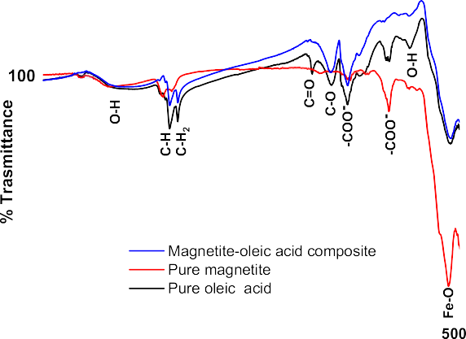

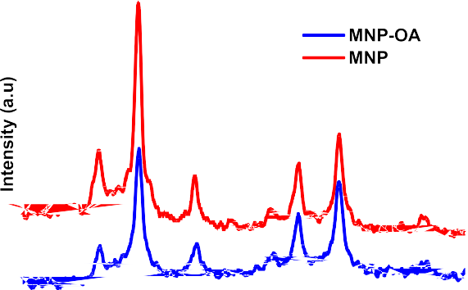
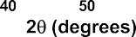
Fig. 1. FTIR spectra of MNP, OA and MNP-OA composite.
Fig. 2. X-Ray diffractogram of MNP and MNP-OA composite including refer-ence peaks for synthetic magnetite.

    - Transmission Electron Microscopy (TEM)
TEM images and the calculated size of the MNP and MNP-OA are shown in Fig. 3a and b. The TEM micrograph of the MNP and MNP-OA show a spherical shape. A strong magnetic dipole-dipole interaction was shown by uncoated magnetite causing big clusters and bigger particle size (Shete et al., 2015). The agglomeration in the nanometric size particles of the MNP was due to the absence of a surface capping agent (Taufiq et al., 2017; Neto et al., 2018). The MNP average particle size was found to be 18.4 ± 0.5 nm. The MNP-OA in Fig. 3b shows the nanoparticles were better separated from one another as compared with the MNP. This was due to the presence of the carboxylic acid surfactant on the surface of the nanoparticles. The average particle size obtained was 15.6 ± 0.5 nm. Also, after the modification process, a non-magnetic layer was formed on the magnetite surface resulting in a decrease in the particle size of the material. The particles had less degree of aggregation (Shete et al., 2015). When compared to the MNP, the TEM image of the MNP-OA also show better isolation due to the strongly held uniform monolayer coverage of oleic acid (Muthukumaran and Philip, 2016). These results are comparable with the XRD results which showed nanosized material.

    - Thermogravimetric analysis
The thermogravimetric and derivative weight loss analysis of the MNP and MNP-OA composite was performed to understand the thermal stability of the samples. The analysis was done under an inert environ-ment, from 30 to 900 ◦C at a heating rate of 10 ◦C /min as shown in Fig. 4. The MNP curve (Fig. 4a) shows four weight loss processes. the initial weight loss is observed at a temperature below 100 ◦C corre-sponding to the evaporation of adsorbed water (Abboud et al., 2015). The second weight loss was observed at temperature between 260—350
      - C which is due to the loss of pore bound water. The third weight loss at 66—670 ◦C has been attributed to the phase transition from Fe₃O₄ to FeO, (Zhang et al., 2018) and the last weight loss was observed at around 786 because of the deoxidation of FeO since the TGA/DTA analysis was achieved under the nitrogen atmosphere. MNP-OA composite (Fig. 3b) showed similar degradation profile with additional degradation peaks due to the presence of oleic acid. The first weight loss of about 2.1 % at a temperature of 97.4 ◦C, was observed due to the evaporation of adsor-bed water molecules.
The second degradation is observed at 214 ◦C with mass loss per-centage of 24.4 % which is due to strong binding between magnetite and oleic acid molecules (Dadwal and Joy, 2018). The third peak at 340 ◦C
layer with a weight loss of 24.4 %. The second decomposition was due to chemically adsorbed water and showed a weight loss of 28.8 % (Lobato et al., 2016). Petcharoen and Sirivat (2012) observed the same trend in the TGA of the MNP-OA composite. Lastly, the weight loss due to the conversion of magnetite (Fe₃O₄) to ferrous oxide (FeO) appeared at 687–754 ◦C and had a percentage weight loss of 43.9 % (Petcharoen and Sirivat, 2012).

    - Magnetic measurements
Magnetization measurements for MNP and MNP-OA were performed by measuring the applied field dependence of magnetization cycled between 15 and 15 kOe at room temperature and the results are shown in Fig. 5. The magnetic curves for MNP showed small hysteresis in the magnetization and the particles showed superparamagnetic behaviour (Guo et al., 2010). The saturation magnetization (Ms), determined by using the law of approach to saturation for MNP and the coercivity (H_{c}) as shown from the hysteresis loop, was 62.9 emu/g. The magnetization results of the MNP show that it was smaller than that of bulk MNP (92 emu/g) (Ouma and Ofomaja, 2020; Toyos-Rodríguez et al., 2019). The lower value of saturation magnetization may be attributed to the decrease in particle sizes, the disordered surface spin coating at the MNP surface and the change in the degree of inversion (Aliakbari et al., 2015; Lobato et al., 2017). Magnetization slightly reduced from 62.9–59 emu/g after coating magnetite with oleic acid, however, both adsor-bents exhibit magnetic properties.
Similar results on the reduction of the saturation magnetization of magnetite with a reduction in particle sizes have been reported previ-ously (Anbarasu et al., 2015; Viante et al., 2018). The degree of reduc-tion can be attributed to the disordered surface spin layer of magnetite when the size of the resultant particle size decreases, the ratio of the disordered layer to the radius of the MNPs is significant (Anbarasu et al., 2015). Additionally, the existence of a diamagnetic shell that coated on the surface of the MNP can also result in lower Ms values (Viante et al., 2018). In this case, the OA stabilizing agent layer protects the MNP from the oxidation reaction and then decreases the magnetic dipole-dipole interaction between the particles (Jiang et al., 2017).

    - Point zero charge (pHpzc)
Under acid conditions, iron oxides accept protons to form positively charged species as shown in the Eqs. (3) and (4)
Fe — OOH + 2H⁺→Fe — OH⁺ + H₂O (3)

due to chemically adsorbed water with weight loss of 28.8 % was also observed (Lobato et al., 2016). Petcharoen and Sirivat (2012) observed
Fe — OOH + H⁺→FeOOH⁺
(4)

the same trend in the TGA of the MNP-OA composite Lastly, the weight loss due to the conversion of magnetite (Fe₃O₄) to ferrous oxide (FeO) appeared at 687–754 ◦C with a percentage weight loss of 43.9 % (Petcharoen and Sirivat, 2012). The first decomposition due to physi-cally adsorbed water represents the decomposition of the OA molecule
2
As the solution pH increases the amount of H⁺ ions in the solution
reduces thereby reducing the amount of H⁺ ions that will interact with the iron oxide, this then reduces the charge of positive charge on the MNP (Ouma et al., 2019). At high solution pH (alkaline condition) OH—predominates in solution and can extract H⁺ from the Fe–OH producing

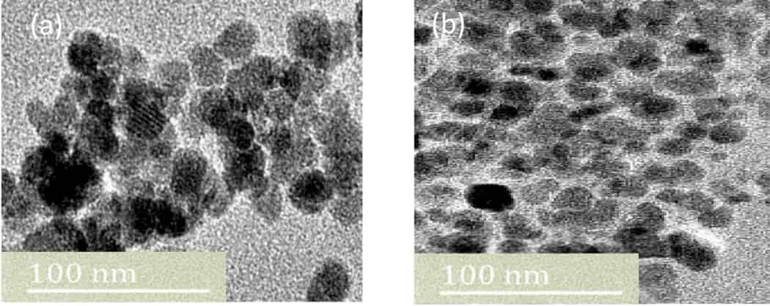
Fig. 3. TEM images of (a) MNP and (b) MNP-OA.

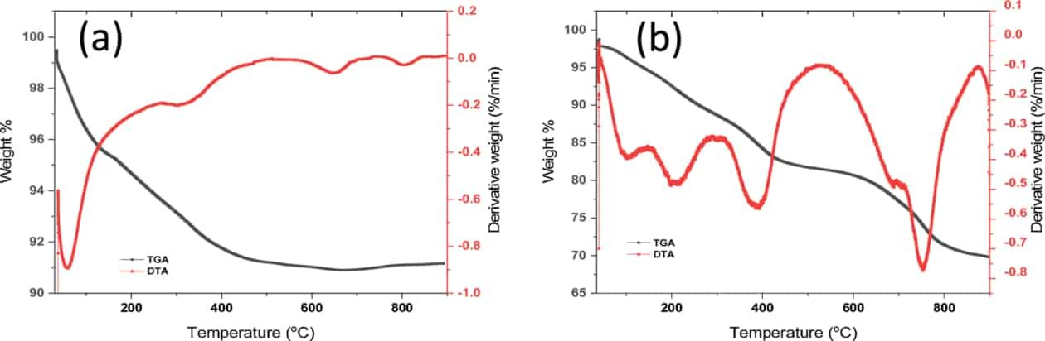
Fig. 4. TGA/DTG diagram of (a) MNP and (b) MNP-OA.
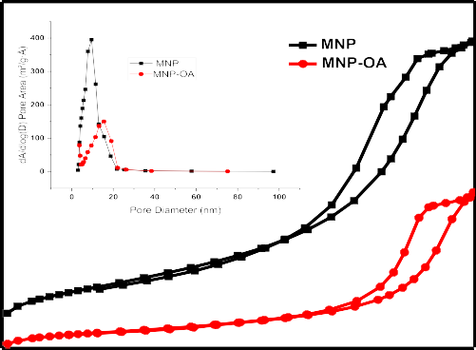

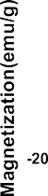
Fig. 6. N₂ adsorption-desorption isotherms of MNP and MNP-OA composite.

Fig. 5. VSM diagram of MNP and MNP-OA composite.

a negatively charged iron oxide species (Fe-O-) as shown in Eq. (5)
Fe — OH + OH—→Fe—O— + H₂O (5)
Therefore, the pHpzc of MNP was observed at solution pH close to neutral (6.9), which is similar to what was observed by other authors (Kim et al., 2016; Ouma and Ofomaja, 2020). A decrease in pHpzc from
6.9 for the MNP adsorbent to 6.4 for the MNP-OA composite was due to the charging acid-base interaction mechanism of metal oxide nano-particles. The charge on the metal oxides in the aqueous solution was due to the adsorption of H⁺ or OH— ions through the protonation and deprotonation mechanism (Bhosale et al., 2015). The presence of the carboxylic group from the organic acid on the MNP surface after the modification process has been shown to result in a decrease in pHpzc (Nigam et al., 2011). When the OA was introduced into the MNP colloid solution, the OA molecules became attached to the MNP surface due to the carboxylic acids having a high affinity for metallic oxides. The bond of FeO–H at the surface of the MNP interacts with the carboxylic acid group of the oleic acid molecule via an acid-base reaction, giving Fe–OC– species with the elimination of H₂O (Kim et al., 2018). Therefore, the amount of available Fe–OH for the acid-base reaction is reduced on the MNP-OA composite which results in reduced pHpzc.

    - BET surface area
Adsorption-desorption isotherms using nitrogen and corresponding size distribution curves for MNP and MNP-OA composite are shown in Fig. 6. The BET surface areas for the samples were found to be 138.9 and
46.6 m²/g. The pore volume and pore sizes were also found to be 0.32
and 0.17, cm³ /g, 9.11 and 14.3 nm, respectively. It can be observed from the result that the BET isotherms of the two samples show a type IV shape indicating the materials were-uniform mesoporous solids. The results also show MNP had two hysteresis loops with increment in the relative pressure region between 0.2 to 0.6 and 0.6–1.0 while MNP-OA composite had two hysteresis loops between 0.2 to 0.6 and 0.6–1.0. This may indicate the presence of interparticle porosity probably due to the agglomeration of nanoparticles resulting in broad pore size of mesopores and micropores.
The isotherm curves also show that after coating the pure magnetite with the oleic-organic carboxylic acid a decrease in the BET surface area was observed with a decrease in nitrogen adsorption. The reduction of the BET surface area was caused by the functionalization of the MNP surface with hydrophobic carboxylic acid causing a strong bond of the organic molecule onto the surface iron atoms specific surface area since the exposed area is covered by the carboxylic molecules resulting from functionalization (Guivar et al., 2017; Ye and Ariya, 2015).

  - Adsorption studies

    - Effect of solution pH on Benzene adsorption
The effect of solution pH on the adsorption of benzene using MNP and MNP-OA composite was studied in the pH range 3–12 and the re-sults are shown in Fig. 7. The plots showed that the adsorption capacity of both samples increased from pH 3, reaching a maximum at pH 7. Although MNP-OA composite had the least capacity at pH 3 but had the highest capacity at pH 7. Above pH 7, the adsorption capacities of both adsorbents were found to decrease with an increase in solution pH until pH 12. The MNP-OA composite had the highest adsorption capacity of
77.1 mg/g and MNP had an adsorption capacity of 59.5 mg/g.

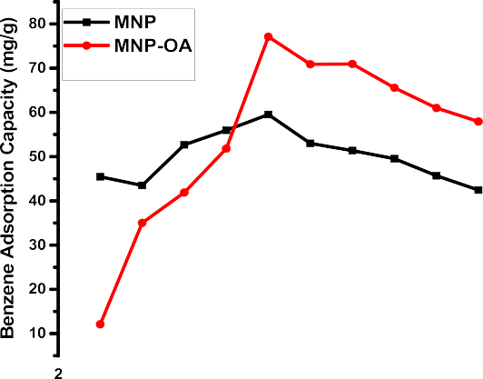
    - Effect of adsorbent dose
The effect of the adsorbent mass on the uptake of benzene from aqueous solution is displayed in Fig. 8. It was observed that benzene uptake percentages of MNP and MNP-OA increased as the adsorbent mass increased from 0.05 to 1.5 g, while the adsorbent capacity of benzene decreased as the adsorbent mass increased. The highest ben-zene percentage removal was observed to be 75.1 and 86.4 % for MNP and MNP-OA composite, respectively. The adsorbent capacity of the MNP-OA reduced from 77.1–3.4 mg/g while the MNP on the other hand, reduced from 59.51 to 2.52 mg/g. The decrease in adsorption capacity was due to an increase in the number of adsorbent particles with con-stant benzene concentration. While the increase in benzene percentage removal was attributed to an increase in the number of adsorbent sites. Therefore, the amount of 0.1 g was taken as the optimum dose for further benzene adsorption studies.

Fig. 7. Effect of initial solution pH on benzene uptake on MNP and MNP-OA composite.

Therefore, the optimum solution pH for both adsorbents was at pH 7. The variation in adsorption with a change in pH may be explained by the following mechanism. As the solution pH increases the amount of H⁺ ions in the solution reduces thereby reducing the amount of H⁺ ions that will interact with the iron oxide, therefore, allowing for the interaction between pollutant and adsorbent. This will explain the increase in adsorption capacity with increasing solution pH from 3 to 7.
The adsorption of benzene onto the surface of the MNP and MNP-OA composite can arise from the interaction between Fe²⁺ and Fe³⁺ and the π electrons groups of benzene. This interaction can be explained by acid-base chemistry, where the delocalized π electrons of the aromatic ring of benzene are capable of sharing electrons (basic character) through σ bonding with the unfilled 3d metal orbital of the iron cations (acidic character). Electron donation from the phenyl ring of each benzene compound to surface iron atoms of MNP has been suggested (Joseph et al., 2000; Sasaki and Tanaka, 2011). This π-electron interaction de-pends on the available surface-active sites on the adsorbent, structure, orientation as well as the configuration of the adsorbate which could potentially activate side-chain interactions (Joseph et al., 2000). The reduction in adsorption capacity at high pH can be explained by using the pH_{pzc} of the adsorbents and the presence of the OH— in the solution. The pH_{pzc} was 6.9 and 6.4 for MNP and MNP-OA composite, respec-tively. Therefore, at solution pH above the pH_{pzc} of the adsorbents, their surfaces will become negative thereby repelling the π electrons system in the rings of the pollutants. This will result in a reduction in the approach of the pollutants to the adsorbent surface causing a reduction in adsorption capacity.
    - Effect of initial concentration and contact time
Adsorption of benzene on MNP and MNP-OA was carried out at concentrations ranging from 100 to 350 mg/dm³ at different contact time and the results are presented in Fig.9a–b. The figures reveal that the initial rapid uptake of Benzene onto MNP and MNP-OA occurred in the first 3 min of contact followed by a gradual increase until reaching an almost constant stage at the end of adsorption process. This is attributed to the fact that at the initial stage of adsorption process, the surface of the adsorbent materials was empty and the adsorption sites were free while at the end of adsorption process, the surface of the adsorbents were saturated with benzene molecules. The amount of benzene removed was seen to increase with an increase in initial benzene con-centration from 100 to 350 mg/dm³. The adsorption capacity of benzene increased from 26.89 to 63.66 mg/g for MNP and from 34.88 to 72.48 mg/g for MNP-OA composite. An increase in adsorption capacity with increasing initial concentration suggests that the adsorption process is driven by the concentration driving force (Ofomaja et al., 2013). As the initial concentration is increased, benzene molecules are forced to the surface of the adsorbent by a concentration difference. This influence cannot be attributed to the surface area of the MNP-OA particles but can be attributed to the higher carbon content of the oleic acid molecule which increases the affinity of the surface of the benzene. The results also shows although adsorption studies were conducted for 120 min, equilibrium was attained within 60 min of contact (Fig. 9).

    - Kinetics modelling
The pseudo-first-order kinetic model follows adsorption kinetics which proceeds by diffusion through a boundary layer. While adsorption processes that proceed by surface chemisorption are described by the pseudo-second-order model as shown in Eqs. (6) and (7).
log(q — q ) = log(q ) — k1 t (6)
^{e} ^{t} ^{e} 2.303

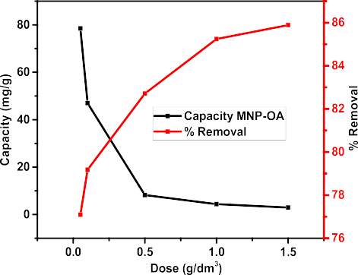
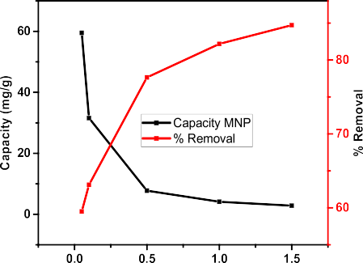
Fig. 8. Effect of adsorbent dose on benzene uptake on MNP and MNP-OA composite.

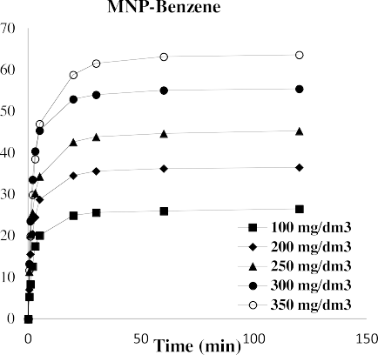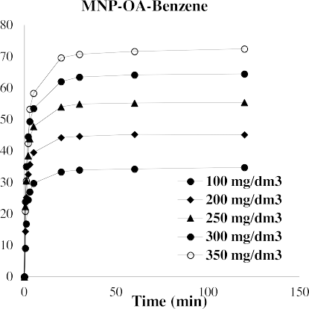

Fig. 9. Adsorption kinetics of Benzene on MNP and MNP-OA composite. Initial pH: 7, adsorbate dose: 0.1 g/dm³, solution volume: 10 mL, agitation speed: 300 rpm, temperature: 299 K.

The pseudo-first-order equation can be written as
q = q 1 — exp^{—k}1 t) (7)
t
e

where q_{t} and q_{e} are the amounts adsorbed at time t and equilibrium and k₁ is the rate constant of the pseudo-first-order.
Tables 1 and 2 show the effect of concentration of benzene onto MNP and MNP-OA adsorbents modelled using the pseudo-first and pseudo-

Table 2
Kinetic data for benzene adsorption onto MNP-OA composite.

Kinetic model | 100 mg/ dm³ | 200 mg/ dm³ | 250 mg/ dm³ | 300 mg/ dm³ | 350 mg/ dm³
Pseudo-first
order
Exp. q (mg/g) 34.79 45.15 55.39 64.49 72.48

second kinetic models. The tables also indicate the fit of the models
determined using the coefficient of correlation, r², and % variable. The
Model q (mg/
g)
33.55 43.72 53.14 61.38 70.00

r² values for the pseudo-second-order models for MNP and MNP-OA were higher than those of the pseudo-first-order model. Higher values of r² signify a better fit of the model to the experimental data while lower values of percentage error also signify a better fit of the model. The pseudo-first-order and pseudo-second-order rate constant experimental adsorption capacities for MNP and MNP-OA adsorbent increased with increasing concentration of benzene. The predicted capacities of the pseudo-second-order model at all concentrations were closer to the experimental data than the pseudo-first-order model. The pseudo-first-order rate constant for benzene adsorption onto MNP and MNP-OA did not follow any particular trend. This may be because the model does not completely describe the adsorption kinetics. Therefore, we can conclude that the adsorption of benzene onto MNP and MNP-OA follows the pseudo-second-order kinetics model. The results of the pseudo-second-order model assumes that the mechanism of uptake involves valence forces through the sharing or exchange of electrons between

Table 1
Kinetic data for benzene adsorption onto MNP.
Kinetic model | 100 mg/ dm³ | 200 mg/ dm³ | 250 mg/ dm³ | 300 mg/ dm³ | 350 mg/ dm³
Pseudo-first order

k₁ (g/mg min) 0.6207 0.7190 0.7588 0.7195 0.4945
r² 0.9911 0.9841 0.9695 0.9673 0.9846

%Variable | 1.144 | 4.184 | 11.284 | 16.471 | 10.873
Error
Pseudo-
second
order
Exp. q (mg/g) | 34.79 | 45.15 | 55.39 | 64.49 | 72.48
Model q (mg/ | 35.41 | 46.08 | 55.91 | 64.72 | 73.74
g)  k₂ (g/mg min) | 0.0264 | 0.0242 | 0.0218 | 0.0174 | 0.0102
h (mg/g min) | 33.1021 | 51.385 | 68.1452 | 72.8830 | 55.4634
r² 0.9932 0.9970 0.9989 0.9990 0.9980
Variable Error 1.094 0.785 0.401 0.512 1.377
adsorbents and benzene molecules (Ho and Ofomaja, 2006). The values of the pseudo-second-order rate constant, k₂ were observed to reduce from 0.0182 to 0.0069 g/mg min for MNP but increased from 0.0264 to 0.0102 g/mg min for MNP-OA composite. This difference in the trend of the pseudo-second-order rate constant, k₂, with initial benzene con-centration suggests a different sorption mechanism between the MNP and the MNP-OA adsorbents.
The results further showed that the MNP and MNP-OA initial sorp-tion rate, h, increased with increasing concentration from 100 to 350 mg/dm³. The initial sorption rate determines the rate at which the
Exp. q (mg/g) | 26.48 | 36.49 | 45.30 | 55.41 | 63.66 | pollutant molecules accumulate on the surface of the adsorbent at the
Model q (mg/g) | 26.63 | 35.29 | 43.38 | 53.66 | 61.49 | initial state of the adsorption. The trend in the result shows that as
k₁ (g/mg min) | 0.3678 | 0.4276 | 0.4523 | 0.4900 | 0.3310 | benzene concentration is increased, the rate at which benzene molecules

accumulate on the surface at the initial stage of adsorption increases. Although the h rate increased with increasing benzene concentration, the pseudo-second-order rate constant decreased with benzene con-centration. This could be a result of interaction between adsorbate molecules at high concentrations as they accumulate on the adsorbent surface.
r2 | 0.9938 | 0.9864 | 0.9734 | 0.9912 | 0.9929
%Variable Error | 0.651 | 2.583 | 7.248 | 3.765 | 4.296
Pseudo-second order  Exp. q (mg/g) | 26.48 | 36.49 | 45.30 | 55.41 | 63.66

r² 0.9956 0.9964 0.9964 0.9978 0.9989
Model q (mg/g) | 26.44 | 37.31 | 45.67 | 56.63 | 65.57 | The comparison of the pseudo-second-order model adsorption ca-
k₂ (g/mg min) | 0.0182 | 0.0167 | 0.0149 | 0.0129 | 0.0069 | pacities of different adsorbents as reported in the literature are shown in
h (mg/g min) | 13.505 | 23.247 | 31.078 | 41.370 | 29.666 | Table 3. The results show that the prepared MNP and MNP-OA

Variable Error 0.4625 0.691 0.674 0.923 0.685
adsorption capacities for benzene were higher and were in line with

Table 3
Pseudo-second order capacities of selected adsorbent materials.
desorption as compared with the MNP. This can be attributed to the stronger bonds formed between benzene and the modified magnetic

Material Benzene adsorption Capacity (mg/g)
Refs.
adsorbents. The results in Fig.10b show five adsorption/desorption cy-cles of benzene using methanol as the desorbing agent. The plots reveal

PEG-Montmorillonite 6.250 (Vidal and Volzone, 2009)
that the adsorption capacities of benzene onto MNP and MNP-OA reduced with the increasing number of cycles. The decrease in adsorp-

Purolite-macronet® MN-202
Carbone CD-500 | 50.778 | (Hackbarth et al., 2014)
Smectite organoclay | 2.040 | (Carvalho et al., 2012)
Mesoporous carbon | 2.476 | (Konggidinata et al.,
(OMC) | 2017)
Hydrophobic Zr metal | 23.200 | (Navarro Amador et al.,
 |  | 2018)
Na-P1 zeolite | 0.0176 | (Bandura et al., 2017)
MNP | 63.655 | This study
MNP-OA | 72.480 | This study

62.496 (Hackbarth et al., 2014)
tion capacities was lower for MNP (36.48—25.68 mg/g) and MNP-OA
lies between (45.14—34.22 mg/g). The higher reduction in adsorption capacities MNP-OA can be attributed to loss and of adsorbent mass deactivation of active sites.
The MNP-OA composite had a lower desorption percentage than the MNP. This is attributed to the additional interactions that occur between the benzene, and the MNP-OA composites surface such as π-π and hy-drophobic interactions. It can be concluded that all the prepared ad-sorbents were favourable for benzene adsorption and can be applied for at least three cycles before significant reduction in adsorption capacity.

those reported in the literature. Among the ones reported in the litera-ture, only the Carbon 119 showed higher adsorption capacities. There-fore, it can be said that the material produced was effective for benzene removal from aqueous solution.

  - Desorption and reuse

Desorption and reusability studies of an adsorbent are key attributes for industrial applicability. Fig. 10a shows methanol and water were used in the recovery of adsorbed benzene and desorption was calculated following Eq. (8)
Desorption (%) = amount desorbed x 100 (8)
amount adsorbed
The desorption trend of benzene using water and methanol followed the order MNP > MNP-OA. The trend observed can be explained by the difference in water solubility of the organic pollutant and in terms of
type and number of bonds formed (Bandura et al., 2017). The results showed that the MNP-OA composite had less desorption percent as compared to MNP. This can be attributed to the fact that MNP-OA has more bonding interactions such as the π-π and hydrophobic interactions than the MNP. This mechanism is based on the electron-donating ability of the phenyl ring in each benzene compound to the D-orbitals of iron in magnetite. Methyl substitution on a benzene ring is capable of donating electrons into the ring system thereby activating the ring towards acid-base reactions (Joseph et al., 2000; Sasaki and Tanaka, 2011). Fig. 10a shows that MNP-OA acid composites had a lower percentage of

  - A plausible mechanism of adsorption

Adsorption of benzene onto adsorbents has been reported to be via several interactions such as polar, hydrophobic, electron donor acceptor and hydrogen bonding. The involvement of various functional groups in benzene removal mechanism was elucidated based on the FTIR analysis in the wavelength range of 4000—500 cm^{—1}. FTIR spectra of MNP and MNP-OA nanocomposite before and after benzene adsorption are shown in. Fig. 11a and b. The main difference in the MNP and MNP-OA spectra before and after 4-benzene are observed to be the hydroxyl and carbonyl groups. The broad OH stretching vibration at 3429 cm⁻¹ on the MNP was observed to have increased in intensity and shifted to 3304 cm⁻¹ after benzene adsorption. The broad OH stretching vibration on MNP-OA at 3310 cm⁻¹ on the other hand was observed to have slightly reduced in intensity. The two sharp C–H peaks at 2919 and 2850 cm⁻¹ were observed to have reduced in intensity and slightly shifted to 2912 and 2843 cm⁻¹ respectively, after benzene adsorption. The two sharp C–H groups were observed to have shifted from 2983 and 2899 cm⁻¹ to 2910 cm^{-1,} formed one peak and reduced in intensity. The shifting of these peaks to lower wavenumber and dissapearance of some peaks hs been reported to be due to the existence of dipole hydrogen bonding and protonation of negative charges (Kuznetsova et al., 2000). On the other hand, the shifting of peaks to higher wavenumber indicate the presence of strong electrostatic interactions (Gu et al., 1994). The peaks for OH, C–O, COO and CH– slightly shifted to lower wavenumber, and reduction and increase in some of the peaks observed for both MNP and MNP-OA indicated dipole hydrogen bonding and protonation of

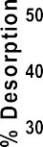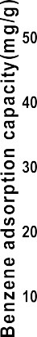
Fig. 10. (a) Desorption studies of benzene from MNP and MNP-OA composite (b) Recycling of MNP and MNP-OA after five cycles of adsorption/desorption.

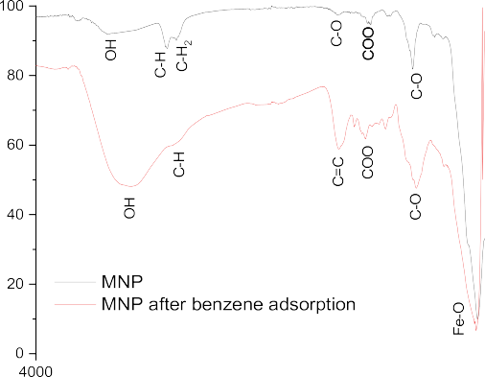

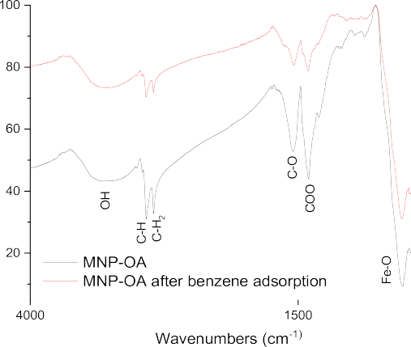
Fig. 11. (a) FTIR spectra before and after benzene adsorption onto (a) MNP and (b) MNP-OA composite.

negatively charged groups. The band at 1634 cm⁻¹ representing the stretching vibration of C–C in the aromatic ring apperead on the MNP
nanoparticle after benzene adsorption. The appearance of the peak may be ascribed to the conjugated effect, showing that the π-π interaction may be the main adsorption mechanism for the removal of benzene using MNP nanoparticles. A reduction and slight shift of the C–O and COO peaks on the MNP-OA nanocomposite shows the interaction be-tween carbonyl oxygen of MNP-OA and the aromatic ring of benzene. The Fe-O stretching vibration corresponding to magnetite nanoparticle was also observed to have shifted from 544 to 554 cm⁻¹ for MNP and slightly reduced in intensity for MNP-OA nanocomposite. It can be deduced that the removal of benzene by MNP and MNP-OA is accom-panied by a couple of machanisms including hydrophobic interaction, hydrogen bonding and π-onjugative interactions.

Conclusion

The study investigated the synthesis of magnetic oleic acid composite via the one-step microwave synthesis method. The interaction between the functional groups of MNP and OA was confirmed by the presence of carboxylic acid. The materials had crystallographic structure, the peaks became broad after modification confirming the interaction between the surface O–H group of the MNP and the organic molecule. The decrease in the BET surface area after modification was due to the functionali-zation of MNP with a hydrophobic carboxylic acid. The VSM results showed superparamagnetic behaviour which is a great aid in adsorption studies. The reduction of pH_{pzc} after coating indicates the charging-acid base interaction mechanism of the metal oxide. The optimum solution pH of 7, and 0.1 g adsorbent dose at 60 min contact time were observed for the removal of benzene onto MNP and MNP-OA was achieved at pH
7. The adsorption capacity of both adsorbents increased with an increase in benzene concentration signifying that the adsorption process is driven by a concentration driving force. The pseudo-second-order kinetics gave the best fit.

CRediT authorship contribution statement

Makhosazana Masuku: Investigation, Writing - original draft. Linda Ouma: Visualization, Writing - review & editing. Agnes Pholosi: Conceptualization, Methodology, Supervision, Writing - review & editing.

Declaration of Competing Interest

The authors report no declarations of interest.

Acknowledgments

The authors would like to acknowledge the Vaal University of Technology and Sasol Limited (Sasol University Collaboration) for funding the study. The authors are thankful to the supervisor, the late Professor Augustine Ofomaja for his contribution in making this research possible.

References

Abboud, M., Youssef, S., Podlecki, J., Habchi, R., Germanos, G., Foucaran, A., 2015.
Superparamagnetic Fe3O4 nanoparticles, synthesis and surface modification. Mater. Sci. Semicond. Process. 39, 641–648.
Ali, M.E.M., Abdelsalam, H., Ammar, N.S., Ibrahim, H.S., 2018. Response surface methodology for optimization of the adsorption capability of ball-milled pomegranate peel for different pollutants. J. Mol. Liq. 250, 433–445.
Aliakbari, A., Seifi, M., Mirzaee, S., Hekmatara, H., 2015. Influence of different synthesis conditions on properties of oleic acid-coated-Fe3O4 nanoparticles. Biomater. Sci. 33, 100–106.
Alves, R.N., Mariz, C.F., Paulo, D.Vde, Carvalho, P.S.M., 2017. Toxicity of effluents from gasoline stations oil-water separators to early life stages of zebrafish Danio rerio. Chemosphere 178, 224–230.
Anbarasu, M., Anandan, M., Chinnasamy, E., Gopinath, V., Balamurugan, K., 2015.
Synthesis and characterization of polyethylene glycol (PEG) coated Fe 3O4 nanoparticles by chemical co-precipitation method for biomedical applications. Spectrochim. Acta - Part A Mol. Biomol. Spectrosc. 135, 536–539.
Arabi, M., Ghaedi, M., Ostovan, A., 2017. Development of a lower toxic approach based on green synthesis of water-compatible molecularly imprinted nanoparticles for the extraction of hydrochlorothiazide from human urine. ACS Sustain. Chem. Eng. 5, 3775–3785.
Baharuddin, A.A., Ang, B.C., Abu Hussein, N.A., Andriyana, A., Wong, Y.H., 2018.
Mechanisms of highly stabilized ex-situ oleic acid-modified iron oxide nanoparticles functionalized with 4-pentynoic acid. Mater. Chem. Phys. 203, 212–222.
Bandura, L., Kołodyn´ska, D., Franus, W., 2017. Adsorption of BTX from aqueous solutions by Na-P1 zeolite obtained from fly ash. Process Saf. Environ. Prot. 109, 214–223.
Bateer, B., Qu, Y., Meng, X., Tian, C., Du, S., Wang, R., Pan, K., Fu, H., 2013. Preparation and magnetic performance of the magnetic fluid stabilized by bi-surfactant. J. Magn. Magn. Mater. 332, 151–156.
Bhatnagar, A., Sillanp¨aa¨, M., Witek-Krowiak, A., 2015. Agricultural waste peels as versatile biomass for water purification - A review. Chem. Eng. J. 270, 244–271.
Bhosale, S.V., Suryawanshi, S.R., Bhoraskar, S.V., More, M.A., Joag, D.S., Mathe, V.L., 2015. Influence of morphology and crystallinity on field emission properties of NiFe 2 O 4 nanoparticles grown by high-temperature vapor phase condensation route. Mater. Res. Express 2, 095001.
Carvalho, M.N., da Motta, M., Benachour, M., Sales, D.C.S., Abreu, C.A.M., 2012. Evaluation of BTEX and phenol removal from aqueous solution by multi-solute adsorption onto smectite organoclay. J. Hazard. Mater. 239–240, 95–101.
Castello´, J., Gallardo, M., Busquets, M.A., Estelrich, J., 2015. Chitosan (or alginate)-coated iron oxide nanoparticles: a comparative study. Colloids Surfaces A Physicochem. Eng. Asp. 468, 151–158.
Chaki, S.H., Malek, T.J., Chaudhary, M.D., Tailor, J.P., Deshpande, M.P., 2015.
Magnetite Fe ₃ O ₄ nanoparticles synthesis by wet chemical reduction and their characterization. Adv. Nat. Sci. Nanosci. Nanotechnol. 6, 035009.
Deng, L., Liu, Y., Zhuang, G., Yuan, P., Liu, D., Bu, H., Song, H., Li, L., 2020. Dynamic benzene adsorption performance of microporous TMA+-exchanged

montmorillonite: the role of TMA+ cations. Microporous Mesoporous Mater. 296, 109994.
Dickhout, J.M., Moreno, J., Biesheuvel, P.M., Boels, L., Lammertink, R.G.H., de Vos, W. M., 2017. Produced water treatment by membranes: a review from a colloidal perspective. J. Colloid Interface Sci. 487, 523–534.
Gu, B., Schmitt, J., Chen, Z., Liang, L., McCarthy, J.F., 1994. Adsorption and desorption of natural organic matter on iron oxide: mechanisms and models. Environ. Sci.
Technol. 28, 38–46.
Guivar, J.A.R., Sadrollahi, E., Menzel, D., Fernandes, E.G.R., Lo´pez, E.O., Torres, M.M., Arsuaga, J.M., Arencibia, A., Litterst, F.J., 2017. Magnetic, structural and surface properties of functionalized maghemite nanoparticles for copper and lead adsorption. RSC Adv. 7, 28763–28779.
Guo, L., Liu, G., Hong, R.Y., Li, H.Z., 2010. Preparation and characterization of chitosan poly(acrylic acid) magnetic microspheres. Mar. Drugs 8, 2212–2222.
Hackbarth, F.V., Vilar, V.J.P., De Souza, G.B., De Souza, S.M.A.G.U., De Souza, A.A.U., 2014. Benzene, toluene and o-xylene (BTX) removal from aqueous solutions through adsorptive processes. Adsorption 20, 577–590.
Ho, Y.S., Ofomaja, A.E., 2006. Pseudo-second-order model for lead ion sorption from aqueous solutions onto palm kernel fiber. J. Hazard. Mater. 129, 137–142.
Hussein, M.S., Ahmed, M.J., 2016. Fixed bed and batch adsorption of benzene and toluene from aromatic hydrocarbons on 5A molecular sieve zeolite. Mater. Chem. Phys. 181, 512–517.
Iyengar, S.J., Joy, M., Maity, T., Chakraborty, J., Kotnala, R.K., Ghosh, S., 2016. Colloidal properties of water dispersible magnetite nanoparticles by photon correlation spectroscopy. RSC Adv. 6, 14393–14402.
Jiang, C., Ng, S.M., Leung, C.W., Pong, P.W.T., 2017. Magnetically assembled iron oxide nanoparticle coatings and their integration with pseudo-spin-valve thin films.
J. Mater. Chem. C Mater. Opt. Electron. Devices 5, 252–263.
Joseph, Y., Wühn, M., Niklewski, A., Ranke, W., Weiss, W., Wo¨ll, C., Schlo¨gl, R., 2000. Interaction of ethylbenzene and styrene with iron oxide model catalyst films at low coverages: a NEXAFS study. Phys. Chem. Chem. Phys. 2, 5314–5319.
Kandisa, R.V., Saibaba, K.V.N., 2016. Dye removal by adsorption: a review.
J. Bioremediation Biodegrad. 07, 317.
Khodaei, K., Nassery, H.R., Asadi, M.M., Mohammadzadeh, H., Mahmoodlu, M.G., 2017.
BTEX biodegradation in contaminated groundwater using a novel strain (Pseudomonas sp. BTEX-30). Int. Biodeterior. Biodegrad. 116, 234–242.
Kim, C., Zhang, Z., Wang, L., Sun, T., Hu, X., 2016. Core–shell magnetic manganese dioxide nanocomposites modified with citric acid for enhanced adsorption of basic dyes. J. Taiwan Inst. Chem. Eng. 67, 418–425.
Kim, B., Lee, Y.R., Kim, H.Y., Ahn, W.S., 2018. Adsorption of volatile organic compounds over MIL-125-NH2. Polyhedron 154, 343–349.
Klekotka, U., Satuła, D., Spassov, S., Kalska-Szostko, B., 2018. Surfactant dependence on physicochemical properties of magnetite nanoparticles. Colloids Surfaces A Physicochem. Eng. Asp. 537, 452–459.
Konggidinata, M.I., Chao, B., Lian, Q., Subramaniam, R., Zappi, M., Gang, D.D., 2017.
Equilibrium, kinetic and thermodynamic studies for adsorption of BTEX onto Ordered Mesoporous Carbon (OMC). J. Hazard. Mater. 336, 249–259.
Korpany, K.V., Majewski, D.D., Chiu, C.T., Cross, S.N., Blum, A.S., 2017. Iron oxide surface chemistry: effect of chemical structure on binding in benzoic acid and catechol derivatives. Langmuir 33, 3000–3013.
Kuznetsova, A., Mawhinney, D.B., Naumenko, V., Yates Jr., J.T., Liu, J., Smalley, R., 2000. Enhancement of adsorption inside of single-walled nanotubes: opening the entry ports. Chem. Phys. Lett. 321, 292–296.
Li, D., Jiang, D., Chen, M., Xie, J., Wu, Y., Dang, S., Zhang, J., 2010. An easy fabrication of monodisperse oleic acid-coated Fe3O 4 nanoparticles. Mater. Lett. 64, 2462–2464.
Lobato, N.C.C., Ferreira, Aˆde M., Mansur, M.B., 2016. Evaluation of magnetic
nanoparticles coated by oleic acid applied to solvent extraction processes. Sep. Purif. Technol. 168, 93–100.
Lobato, N.C.C., Mansur, M.B., Ferreira, A., de, M., 2017. Characterization and chemical stability of hydrophilic and hydrophobic magnetic nanoparticles. Mater. Res. 20, 736–746.
Mahdavi, M., Ahmad, M.Bin, Haron, M.J., Namvar, F., Nadi, B., Ab Rahman, M.Z., Amin, J., 2013. Synthesis, surface modification and characterisation of biocompatible magnetic iron oxide nanoparticles for biomedical applications. Molecules 18, 7533–7548.
Mosafer, J., Abnous, K., Tafaghodi, M., Jafarzadeh, H., Ramezani, M., 2017. Preparation and characterization of uniform-sized PLGA nanospheres encapsulated with oleic acid-coated magnetic-Fe3O4 nanoparticles for simultaneous diagnostic and therapeutic applications. Coll. Surf. A Physicochem. Eng. Asp. 514, 146–154.
Muthukumaran, T., Philip, J., 2016. Effect of phosphate and oleic acid capping on structure, magnetic properties and thermal stability of iron oxide nanoparticles.
J. Alloys. Compd. 689, 959–968.
Navarro Amador, R., Cirre, L., Carboni, M., Meyer, D., 2018. BTEX removal from aqueous solution with hydrophobic Zr metal organic frameworks. J. Environ. Manage. 214, 17–22.
Neto, W.S., Dutra, G.V.S., Jensen, A.T., Araújo, O.A., Garg, V., De Oliveira, A.C., Valadares, L.F., De Souza, F.G., Machado, F., 2018. Superparamagnetic nanoparticles stabilized with free-radical polymerizable oleic acid-based coating.
J. Alloys. Compd. 739, 1025–1036.
Nigam, S., Barick, K.C., Bahadur, D., 2011. Development of citrate-stabilized Fe3O4 nanoparticles: conjugation and release of doxorubicin for therapeutic applications.
J. Magn. Magn. Mater. 323, 237–243.
Niu, H., Mo, Z., Shao, M., Lu, S., Xie, S., 2016. Screening the emission sources of volatile organic compounds (VOCs) in China by multi-effects evaluation. Front. Environ. Sci. Eng. China 10, 1–11.
Ofomaja, A.E., Pholosi, A., Naidoo, E.B., 2013. Kinetics and competitive modeling of cesium biosorption onto chemically modified pine cone powder. J. Taiwan Inst. Chem. Eng. 44, 943–951.
Ofomaja, A.E., Pholosi, A., Naidoo, E.B., 2014. Kinetics and competitive modeling of cesium biosorption onto iron(III) hexacyanoferrate modified pine cone powder. Int. Biodeterior. Biodegradation 92, 71–78.
Ouma, L., Ofomaja, A., 2020. Probing the interaction effects of metal ions in Mn x Fe (3—x) O 4 on arsenite oxidation and adsorption. RSC Adv. 10, 2812–2822.
Ouma, I.L.A., Naidoo, E.B., Ofomaja, A.E., 2017. Iron oxide nanoparticles stabilized by lignocellulosic waste as green adsorbent for Cr(VI) removal from wastewater. EPJ Appl. Phys. 1, 79.
Ouma, I.L.A., Naidoo, E.B., Ofomaja, A.E., 2019. An insight into the adsorption mechanism of hexavalent chromium onto magnetic Pine cone powder. Chemistry for a Clean and Healthy Planet. Springer International Publishing, Cham, pp. 185–195.
Parvizi, N., Rahemi, N., Allahyari, S., Tasbihi, M., 2020. Plasma-catalytic degradation of BTX over ternary perovskite-type La1-x(Co, Zn, Mg, Ba)xMnO3 nanocatalysts. J. Ind. Eng. Chem. 84, 167–178.
Petcharoen, K., Sirivat, A., 2012. Synthesis and characterization of magnetite nanoparticles via the chemical co-precipitation method. Mater. Sci. Eng. B Solid-State Mater. Adv. Technol. 177, 421–427.
Russo, A.V., De Angelis, L.E., Jacobo, S.E., 2018. Adsorption with catalytic oxidation in a recirculating bed reactor for contaminated groundwater. J. Water Process Eng. 23, 129–133.
Salvi, A., Patki, G., Liu, H., Salim, S., 2017. Psychological impact of vehicle exhaust exposure: insights from an animal model. Sci. Rep. 7, 1–8.
Sasaki, T., Tanaka, S., 2011. Adsorption behavior of some aromatic compounds on hydrophobic magnetite for magnetic separation. J. Hazard. Mater. 196, 327–334.
Sheikholeslami, Z., Yousefi Kebria, D., Qaderi, F., 2018. Nanoparticle for degradation of BTEX in produced water; an experimental procedure. J. Mol. Liq. 264, 476–482.
Shete, P., Patil, R., Tiwale, B., Pawar, S., 2015. Water dispersible oleic acid-coated Fe₃O₄ nanoparticles for biomedical applications. J. Magn. Magn. Mater. 377, 406–410.
Sivasankar, V., Gopalakrishna, G.V.T., 2017. Quantification of benzene in groundwater sources and risk analysis in a popular South Indian Pilgrimage City–a GIS based approach. Arab. J. Chem 10, S2523–S2533.
Soares, P.I.P., Alves, A.M.R., Pereira, L.C.J., Coutinho, J.T., Ferreira, I.M.M., Novo, C.M. M., Borges, J.P.M.R., 2014. Effects of surfactants on the magnetic properties of iron oxide colloids. J. Colloid Interface Sci. 419, 46–51.
Sophia, A.C., Lima, E.C., 2018. Removal of emerging contaminants from the environment by adsorption. Ecotoxicol. Environ. Saf. 150, 1–17.
Taufiq, A., Saputro, R., Hidayat, N., Hidayat, A., Mufti, N., Diantoro, M., Patriati, A., Putra, E., Nur, H., 2017. Fabrication of magnetite nanoparticles dispersed in olive oil and their structural and magnetic investigations. In: The 4th International Conference: Sci. Technol. Adv. Mater., 202, pp. 1–8.
Toyos-Rodríguez, C., Calleja-García, J., Torres-Sa´nchez, L., Lo´pez, A., Abu-Dief, A.M., Costa, A., Elbaile, L., Crespo, R.D., Garitaonandia, J.S., Lastra, E., García, J.A., García-Alonso, F.J., 2019. A simple and reliable synthesis of superparamagnetic magnetite nanoparticles by thermal decomposition of Fe(acac) 3. J. Nanomater. 2019, 1–10.
Vasile, E., Serafim, A., Dragusin, D.M., Petrea, C., Iovu, H., Stancu, I.C., 2012. Apatite formation on active nanostructured coating based on functionalized gold nanoparticles. J. Nanopart. Res. 14, 918.
Viante, M.F., Zanela, T.M.P., Stoski, A., Muniz, E.C., Almeida, C.A.P., 2018. Magnetic microspheres composite from poly(ethylene terephthalate) (PET) waste: synthesis and characterization. J. Clean. Prod. 198, 979–986.
Vidal, N.C., Volzone, C., 2009. Analysis of tetramethylammonium-montmorillonite and retention of toluene from aqueous solution. Appl. Clay Sci. 45, 227–231.
Vidal, C.B., Raulino, G.S.C., Barros, A.L., Lima, A.C.A., Ribeiro, J.P., Pires, M.J.R., Nascimento, R.F., 2012. BTEX removal from aqueous solutions by HDTMA-modified Y zeolite. J. Environ. Manage. 112, 178–185.
Wang, X., Ma, C., Xiao, J., Xia, Q., Wu, J., Li, Z., 2018. Benzene/toluene/water vapor adsorption and selectivity of novel C-PDA adsorbents with high uptakes of benzene and toluene. Chem. Eng. J. 335, 970–978.
Yang, K., Peng, H., Wen, Y., Li, N., 2010. Re-examination of characteristic FTIR spectrum of secondary layer in bilayer oleic acid-coated Fe 3O4 nanoparticles. Appl. Surf. Sci. 256, 3093–3097.
Yang, Z., Liu, J., Yao, X., Rui, Z., Ji, H., 2016. Efficient removal of BTEX from aqueous solution by β-cyclodextrin modified poly(butyl methacrylate) resin. Sep. Purif.
Technol. 158, 417–421.
Ye, C.Z., Ariya, P.A., 2015. Co-adsorption of gaseous benzene, toluene, ethylbenzene, m-xylene (BTEX) and SO2 on recyclable Fe3O4 nanoparticles at 0-101% relative humidities. J. Environ. Sci. (China) 31, 164–174.
Zhang, S., Liu, K., Chen, H., Liu, S., 2018. Water-dispersible and quasi-superparamagnetic magnetite nanoparticles prepared in a weakly basic solution at the low synthetic temperature. Mater. Res. Bull. 105, 220–225.
Zhao, L., Lin, Z.R., Ma, Xhong, Dong, Y.H., 2018. Catalytic activity of different iron oxides: insight from pollutant degradation and hydroxyl radical formation in heterogeneous Fenton-like systems. Chem. Eng. J. 352, 343–351.

